20th STARTUP WORLD CUP CHAMPIONSHIP AMONG CHILDREN AND YOUTH
2020 STARTUP WORLD CUP CHAMPIONSHIP
& INTERNATIONAL BUSINESS CAMP
Bournemouth, The United Kingdom
5-11 July, 2020
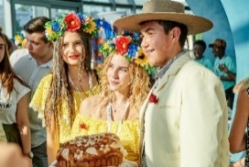
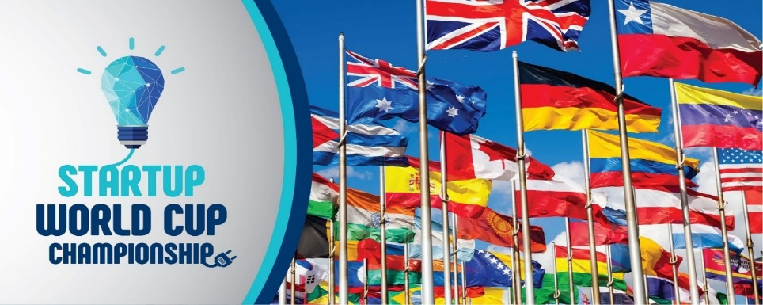

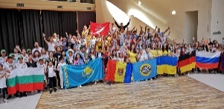

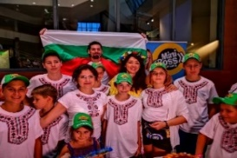

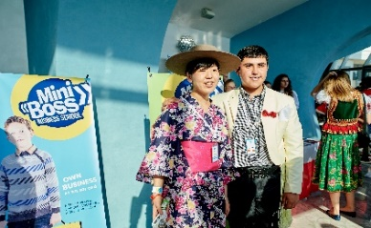
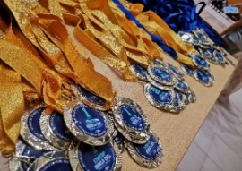
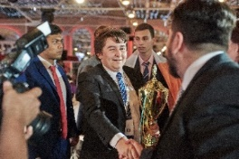

The Champion summer camp of the International education network MINIBOSS & BIGBOSS BUSINESS SCHOOLS (camps.miniboss-school.com) is held annually before the Startup World Championship - STARTUP WORLD CUP CHAMPIONSHIP (SWCC) (www.startupworldcup.biz), which will be held in Bournemouth in 2020 (Great Britain). SWCC World Championships - this is the main annual event in the world for young entrepreneurs, which brings together young national elites from around the world.
The Champion Summer Camp was organized by the Educational Consortium INTERNATIONAL BUSINESS ACADEMY (www.iba-consortium.com) to develop young people (from 6 to 25 years old) in their business qualities and build global business communications; to develop teamwork skills and create business projects from idea to implementation; for the ability to defend their projects on the world stage before a jury consisting of entrepreneurs from around the world.
OPEN LEAGUE was organized for third-party participants.
Each year, for every student of the Education Network MINIBOSS & BIGBOSS BUSINESS SCHOOLS, a visit to the World Championship is the culmination of the course and an essential element of the academic program. At the Championship, students receive an international certificate, and at the end of all courses - International diplomas MINIBOSS BUSINESS SCHOOL; BIGBOSS BUSINESS SCHOOL and INTERNATIONAL BUSINESS ACADEMY.
INTERNATIONAL BUSINESS CAMP HAS 7 MAIN ADVANTAGES:

• INTERNATIONAL CAMP - HUNDREDS OF CHILDREN FROM DIFFERENT COUNTRIES meet annually in this SUPER-CAMP for LEADERS! Coaches run the program in English / Russian / Lithuanian / Bulgarian etc. that will help each child to feel yourself as a part of a global community!

• SKILLS DEVELOPMENT - here children do not just relax, they also develop in an important profile - ENTREPRENEURSHIP.

• HEALTHY ENVIRONMENT – there is an atmosphere of friendship, support, development. The most purposeful children who want their own development and success are invited here, and this creates an atmosphere with strong values.

• ENGLISH LESSONS daily until the World Cup - the kids upgrade well their English skills!

• AGE GROUPS - children and youth in various age groups can participate in the World Championship: MINIBOSS (6-14 years old), BIGBOSS (15-25 years old).

• OPEN LEAGUE - all registered participants can take part in the World Cup through confirmation of registration and presentation of the startup in the prescribed form, as well as payment of the registration fee through the website www.startupworldcup.biz. For students of MINIBOSS & BIGBOSS BUSINESS SCHOOLS payment of registration fee is not required.

• FAMILY CAMP. Supporting family values ​​at MINIBOSS BUSINESS SCHOOL implies family integrity and the fact that the main careers of the child are parents, and the business school helps parents achieve the goal of raising successful and happy family heirs. In this regard, in order to achieve the maximum result for each academic level, parents need to be present and support the child at each stage of growth, at each World Championship. Moreover, it will be the most vivid childhood memories and an incredibly pleasant vacation in the circle of the global MINIBOSS family!

LOCATION

The camp is located on the south coast of England in the city of Bournemouth (107 miles from London). Bournemouth is a seaside resort in the county of Dorset, a popular English resort on the English Channel, adjacent to Poole in the west.

Dorset is a ceremonial non-metropolitan county of England, located in the southwestern part of the country on the English Channel. It consists of the non-metropolitan county of Dorset and two unitary units: Pula and Bournemouth.

Covering an area of ​​2653 km², Dorset is bordered by four other English counties: Devon in the west, Somerset in the northwest, Wiltshire in the northeast and Hampshire in the east. The capital of the county is the city of Dorchester, located in its southern part.
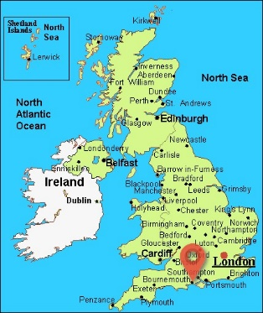

ABOUT BOURNEMOUTH

The name of the city of Bournemouth is translated as “the mouth of the Bourne” (meaning a stream flowing here into the strait). Thanks to the many public buildings in Bournemouth, conferences and congresses are often held.  In 1992, Bournemouth University was organized.  Bournemouth Football Club plays in the Premier League, the top division of English football. | 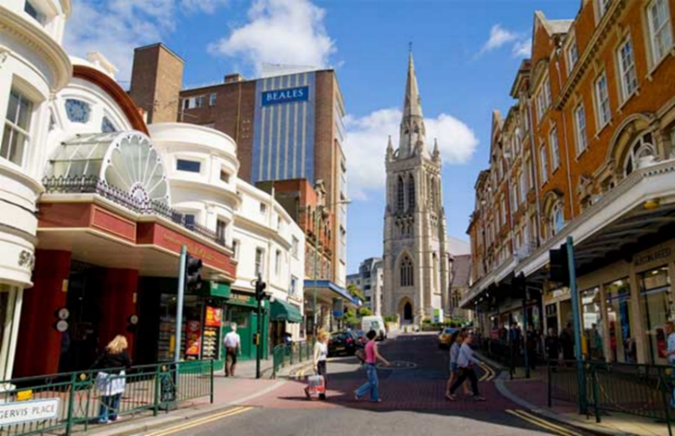
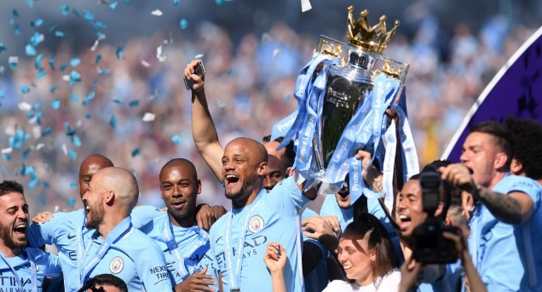 | The territory of modern county was settled by primitive tribes from the Neolithic era. In the first century AD, during the invasion of the island, the Romans conquered the ancient Durotrig tribe living in the south of Great Britain.  During the early Middle Ages, Anglo-Saxons invaded the region.  In the 7th century, Dorset became a county.
The geography of the county is diverse: these are towering chalk cliffs, and steep limestone ridges, and low-lying clay valleys. More than half of the territory of Dorset consists of state-protected reserves, three quarters of the coast are World Heritage sites.  Agriculture has traditionally been the backbone of the county’s economy, but at the moment its role is declining, while tourism is becoming increasingly important. | 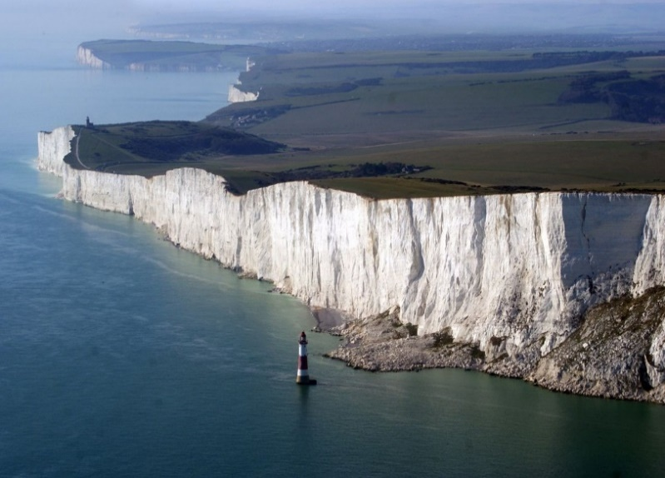

ACCOMMODATION

Accommodation: on-campus of Home Park.
Room: en-suite (modern single rooms with private bathrooms and ample workspace with access to a shared living room).
Conference for SWCC: HILTON VIP CONFERENCE HALL.

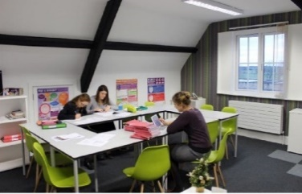
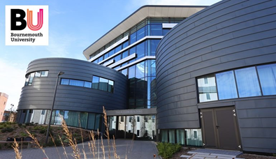
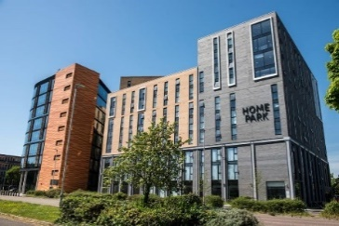
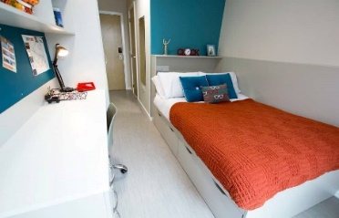

MEAL

MEAL is carried out in the "buffet" system 3 times a day (breakfast, lunch and dinner). Every day the menu contains dishes of local and international cuisine, drinks.
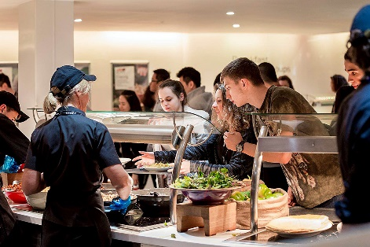
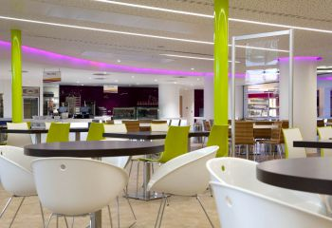
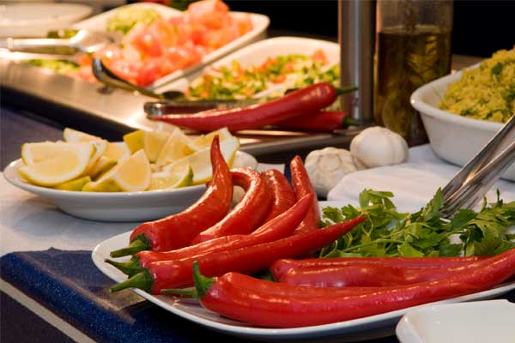

PRICE

PRICE “ALL INCLUSIVE” (without flight and transfer)

- ONE WEEK
International Startup Camp 5-11.07.2020 (7 days / 6 nights):
- Payment before 01.03.2020: £ 1,275 - student up to 18 years; £ 1,455 - adult.
- Payment before 01.05.2020: £ 1,455 - student up to 18 years; £ 1,700 - adult.

- TWO WEEKS
International British Language Camp + Startup Camp 28.06-11.07.2020 (14 days/13 nights):
- Payment before 01.03.2020: £ 1,974 - student up to 18 years; £ 2,354 - adult.
- Payment before 01.05.2020: £ 2,154 - student up to 18 years; £ 2,599 - adult.

The number of seats at this price is limited!
For those who buy vouchers later, there may not be available seats at the main location and locations will be offered nearby (in this case, prices will be specified). Follow the recommendations of branch directors on the dates of purchase of vouchers.

Price includes:

1. Single occupancy in a room with a bathroom;
2. Full board (3 times a day, including lunch every day, except for excursion trips for the whole day);
3. English lessons by BRITISH COUNCIL - from Monday to Thursday (up to 12 students in a group) - 20 lessons/1st week and 8 lessons/2nd week;
4. Lessons with national team leaders in preparation for speaking at the World Cup (1 lesson per day in preparing the project from Monday to Wednesday);
5. Participation in the Cultural Show COUNTRY DAY;
6. Participation in the BBBF - BIGBOSS BUSINESS FORUM;
7. Startup World Cup Championship: semi-final round;
8. Startup World Cup Championship: final round;
9. Awarding ceremony and certification of students of the International educational network MINIBOSS & BIGBOSS BUSINESS SCHOOLS;
10. Gala dinner according to the rules of English etiquette with the dress code Black Tie;
11. The manual in English Course Book;
12. International certificate of short English courses;
13. Full day excursion (London) with a guide # 1;
14. Half-day excursion in England # 2;
15. Half-day excursion in England # 3;
16. A tour of the new at Bournemouth Art University;
17. Evening events and games (according to our schedule) in English with native speakers;
18. Brand photo shoot and access to photos;
19. Professional shooting of video and news stories in 2 languages ​​(English, Russian) for placement on television and in social networks;
20. Intensive training for participants in the OPEN LEAGUE of the World Championship (who are not MINIBOSS & BIGBOSS students);
21. Branded equipment for participants in the World Cup and the International Camp.
Additional payments: • Insurance; • Flights; • Visa; • Visa application; • Transfer,
• Supervised student supervision by experienced teachers - £ 45 per person per week.

OFFICIAL DELEGATION

OFFICIAL DELEGATION OF THE COUNTRY
The official delegations from your country at the World Startup Championship 2020 can consist of:

• Children and youth as participants in the World Cup or spectators,
• Parents as spectators of the World Cup and camp participants,
• Entrepreneurs as members of the International Jury (registration fee of 200 pounds or higher, at the request of the entrepreneur, to contribute to the World Championship Prize Fund in support of the development of a new generation of world leaders). Each entrepreneur as a jury member is officially registered on the site or through franchisees.
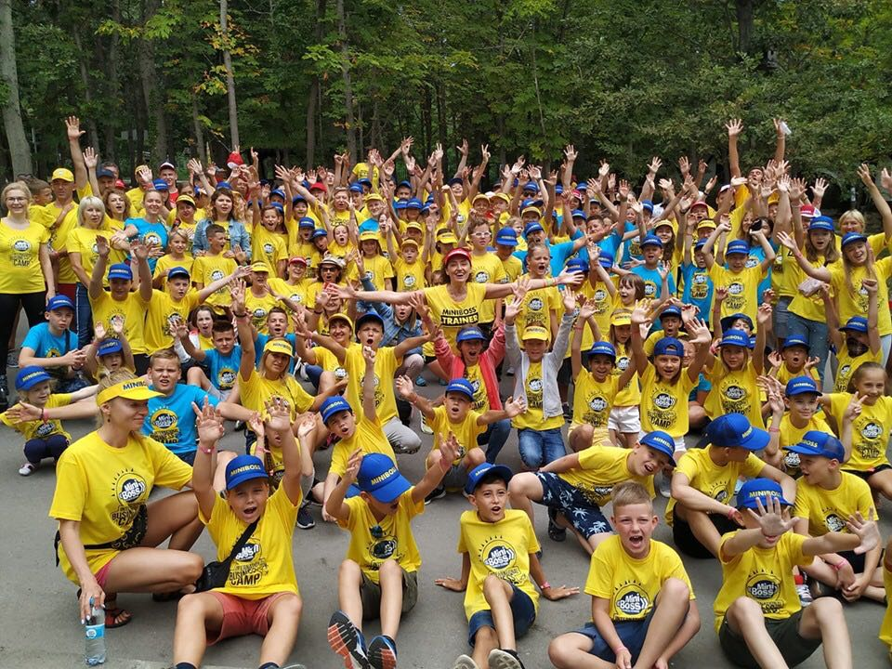
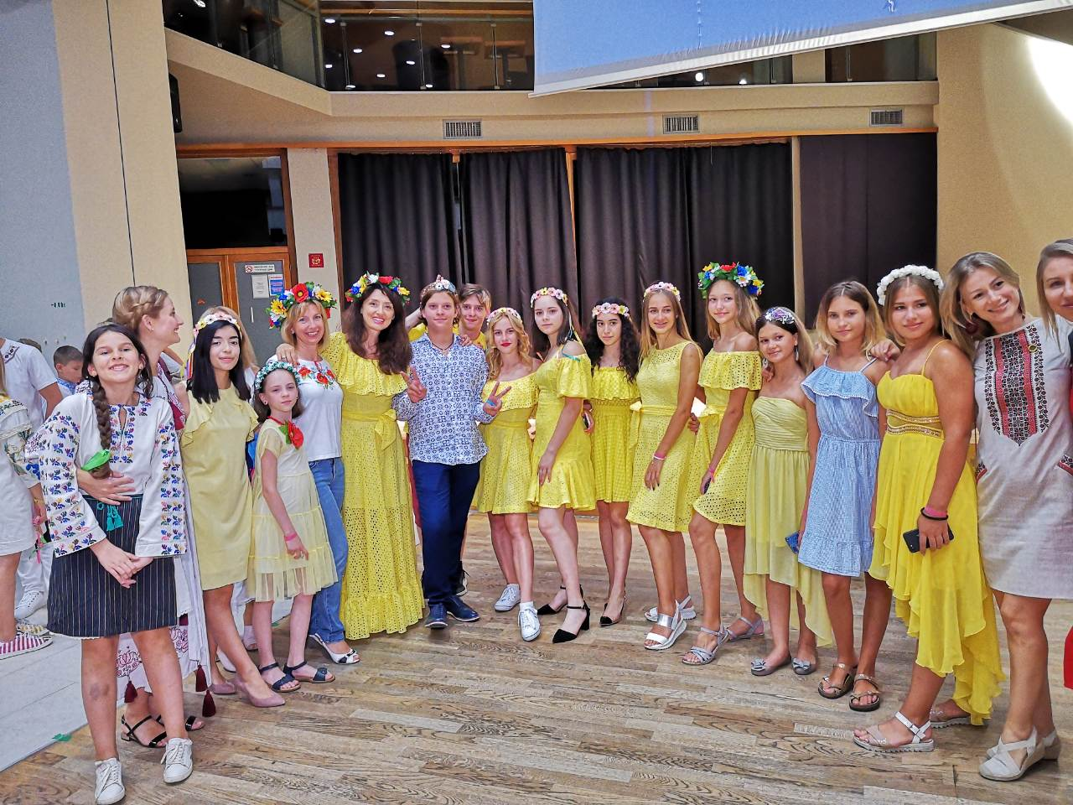

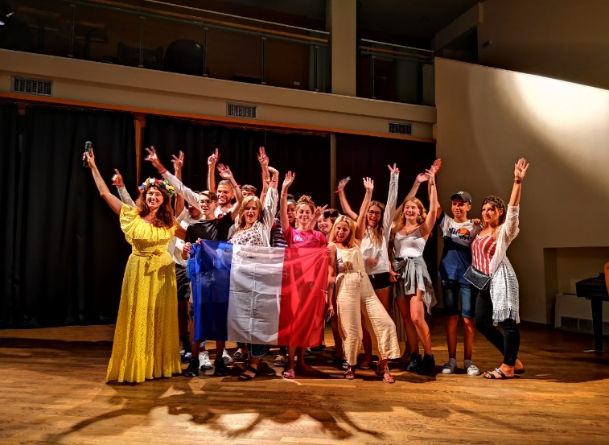
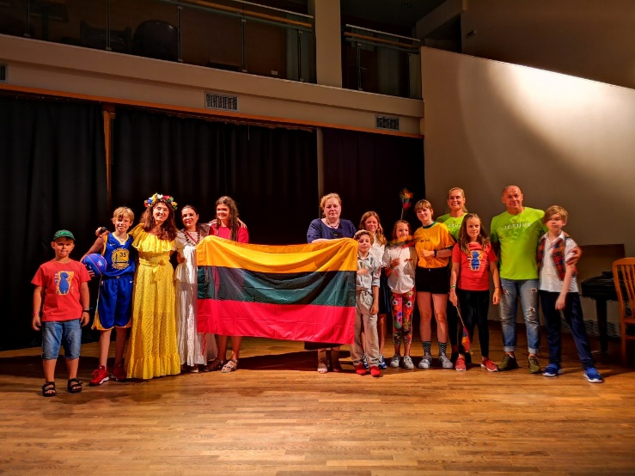

PROGRAM OF THE CHAMPIONSHIP 2020

1^{sr} day 5th July, – NATIONAL DELEGATIONS ARRIVAL, check-in.

2nd day 6th July – GLOBAL DAY OF FRIENDSHIP
In the afternoon: English lessons in groups, the game "Global Friendship".
In the evening, the Cultural Show “PARADE OF COUNTRIES” (national delegations with the flag of their country, national costumes, national stands with treats and souvenirs from that country, national songs and dances from the country).

3rd day 7th July – BRITISH CULTURE
English lessons in groups. Preparation for the World Cup.
GUIDED TOUR FOR HALF-DAY.
Evening Master Class for parents "Family Capital".

4th day 8th July – WORLD CUP CHAMPIONSHIP: SEMI-FINAL
Performances of teams in leagues and in nominations. English lessons in groups.
GUIDED TOUR FOR HALF-DAY.

5th day 9th July – WORLD CUP CHAMPIONSHIP: FORUM AND FINAL
- 1st part: BIGBOSS GLOBAL BUSINESS FORUM 2020 GLOBAL BUSINESS FORUM, business acquaintances and speeches of famous entrepreneurs from different countries - members of the MINIBOSS & BIGBOSS BUSINESS SCHOOLS Global Business Council - on the global stage with the theme "MILLENNIUM CREATIVITY AND TECHNOLOGIES";
- 2nd part: WORLD CHAMPIONSHIP FINAL;
- 3rd part: GALA DINNER & AWARDING CEREMONY. CERTIFICATION.

6th day 10th July - FULL DAY GUIDED TOUR
GUIDED TOUR FOR FULL-DAY.

7th day 11th July – FLIGHT TO GREECE TO THE SUMMER CAMP MINIBOSS & BIGBOSS
Check out the national delegations. Flight to the International Health and Leisure Business Camp
DEPARTURE DAY to Greece.

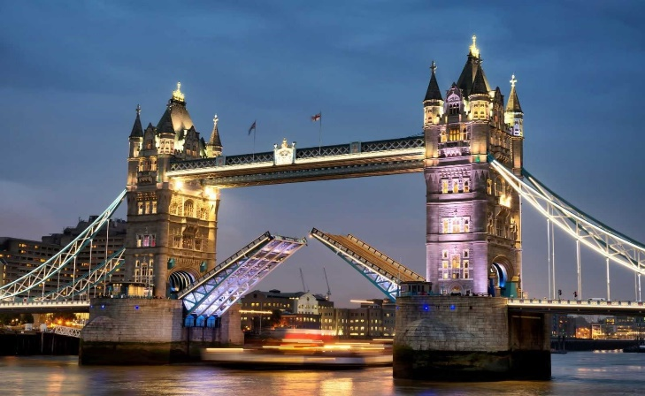

CHAMPIONSHIP SWCC 2020 AWARDS

• CHAMPIONS CUP for the 1st, 2nd, 3rd place:
- BEST COMMERCIAL STARTUP / SIFE Award / Startups in innovative free enterprise;
- BEST SOCIAL STARTUP / SAGE Award / Startups for the development of the global environment;
• GREEN PLANET Award / Startups for solving environmental problems and creating alternative energy sources;
• The UN Gold SDGs for the UN Millennium Development Goals - THE UN SUSTAINABLE DEVELOPMENT GOALS AWARDS;
• Monetary Prizes;
• Special prizes from partners / sponsors;
• Diplomas of Participants;
• Gifts to all participants.

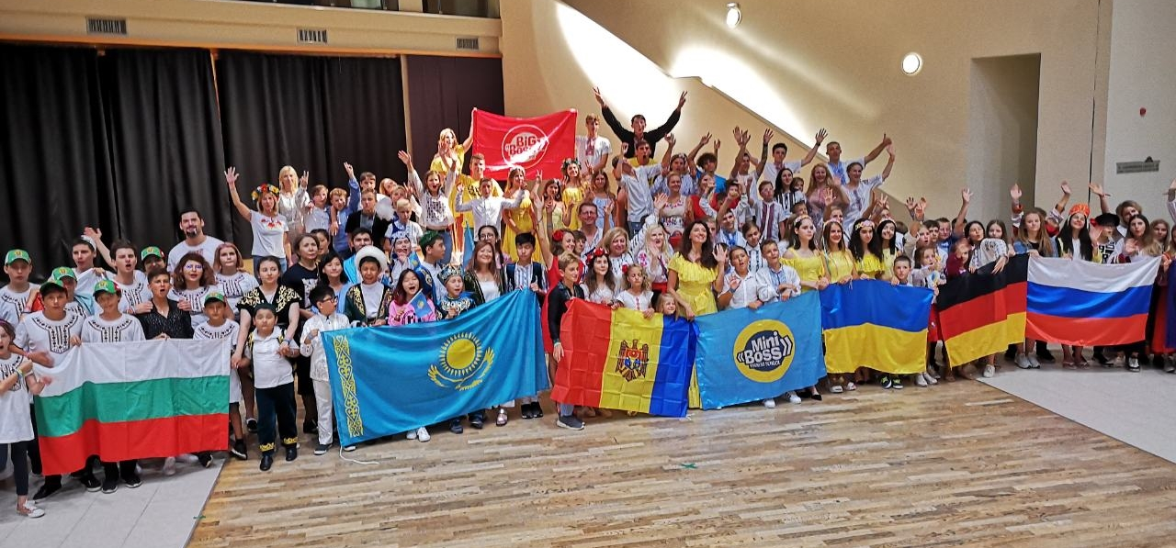

Camps site: camps.miniboss-school.com
Championships site: www.startupworldcup.biz

WELCOME TO STARTUP WORLD CUP!
WELCOME TO THE UK!

