INTERNATIONAL FAMILY BUSINESS CAMP
OLYMPIC 2020 GREECE,
JULY 11-22 (11 DAYS/10 NIGHTS)

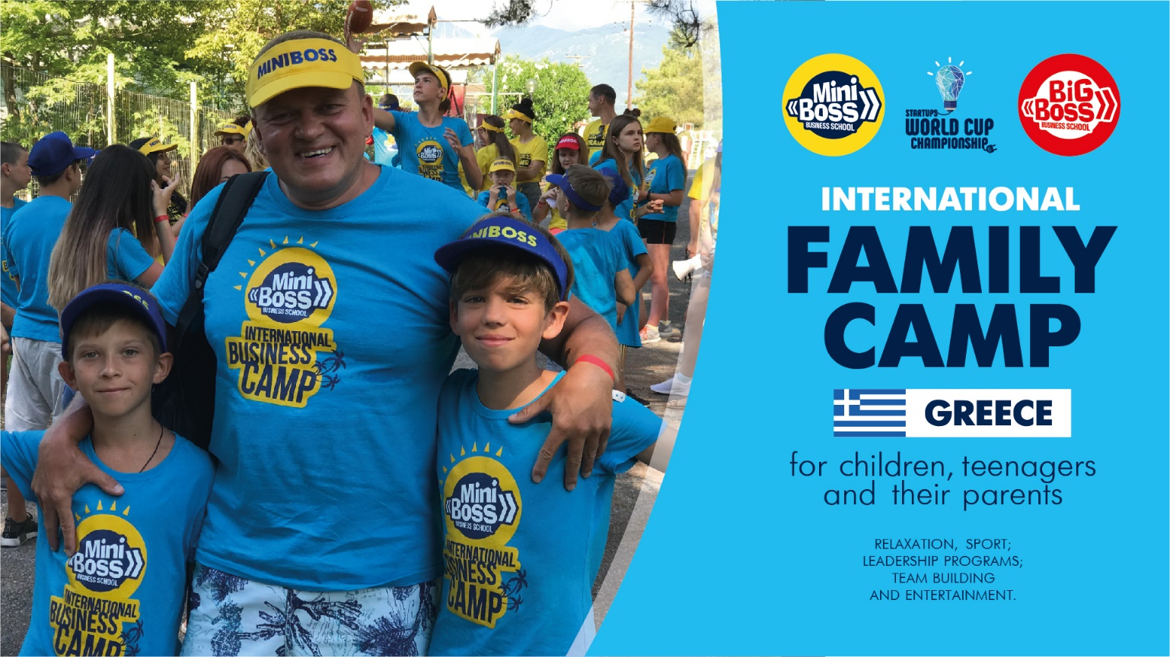

INTERNATIONAL CAMP IN GREECE =
FRIENDS + RECREATION + SPORTS + GAMES + DEVELOPMENT

FIVE MAIN ADVANTAGES:
• REST and WELLNESS. The goal is to make the body healthy and strong! Therefore, in the concept of the camp will be a lot of physical activities (jogging, proper breathing with fresh sea air, stretching with yoga, many sports games (football, volleyball, aqua ball);

- SKILLS DEVELOPMENT. Our camp will be different from all others – children won’t just rest there, they will also develop yourself on a very important profile - LEADERSHIP. MINIBOSS & BIGBOSS LEADERSHIP PROGRAMS are well known worldwide for their effectiveness! It will be unforgettably fun, interesting and useful!

- HEALTHY ENVIRONMENT. A special advantage is a healthy eco-friendly atmosphere. We invite the most purposeful children and youth who want their own successful future, and this creates a strong atmosphere with strong values.
- FAMILY CAMP. Children and their parents are invited. The unique Coach Program "IDEAL" is free for every MINIBOSS & BIGBOSS parent!).

- INTERNATIONAL. Our team of global trainers leads the program in English / Russian /Lithuanian /Bulgarian / etc. Our mentors will do everything to make every child feel part of a global team!

LOCATION
The camp is located on 80 km from Thessaloniki and 25 km from Katerini city, near the sea and at the foot of the majestic Mount Olympus, with a picturesque and extensive beach, that is covered with fine golden sand: ORFEAS Blue Resort, Korinos beach, Katerini, Greece.
www.orfeas-hotels.gr

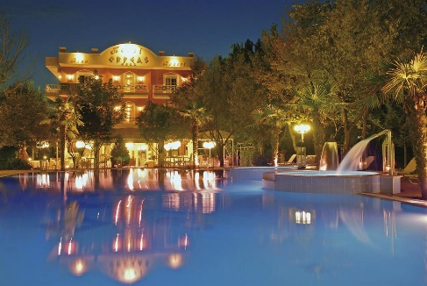 | 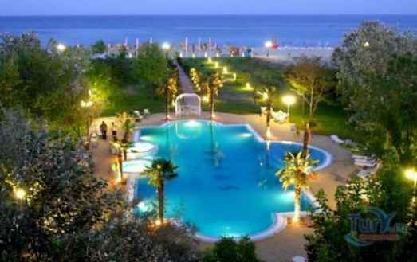 | 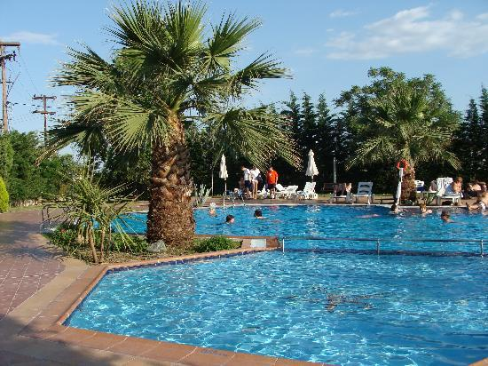
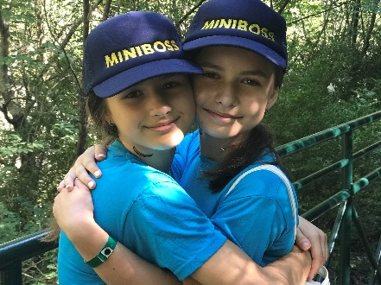 | 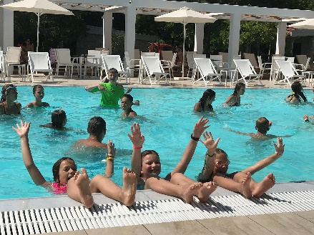 | 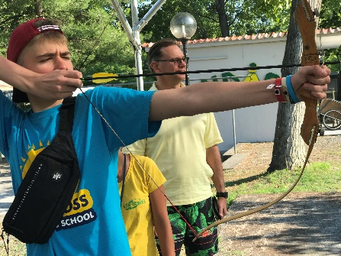

ACCOMMODATION
Accommodation for 3-4 people in the comfortable room. In each room there are 3 or 4 beds; TV; Air conditioning; Fridge; Bedside tables; wardrobe; bathroom with hairdryer, safe deposit.

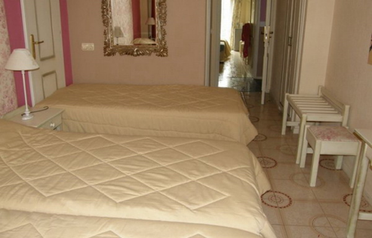 | 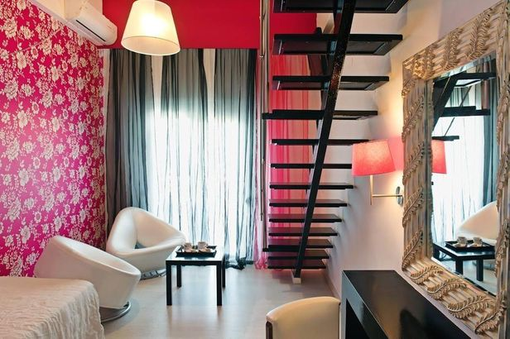 | 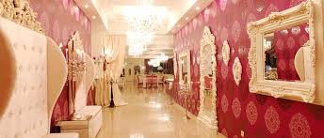

MEAL
MEAL is carried out in the "buffet" system 4 times a day (breakfast, lunch, afternoon snack and dinner). Every day the menu contains fresh fruits and vegetables, soup.
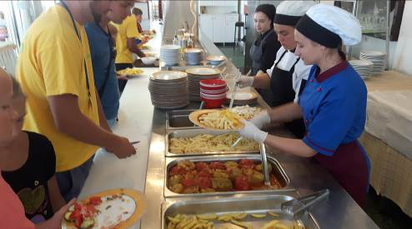 | 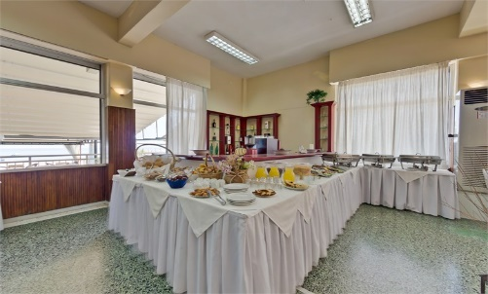 | 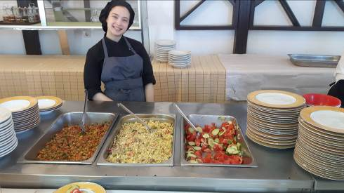
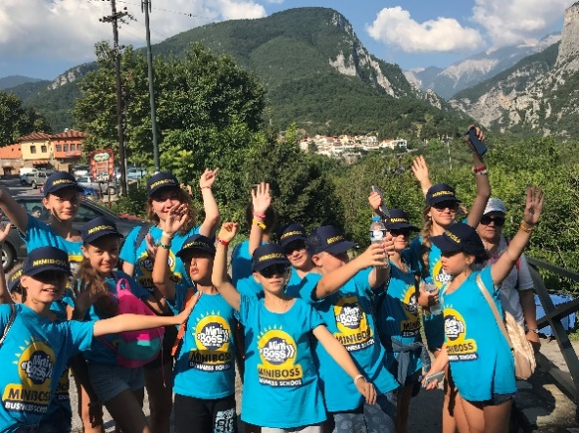 | 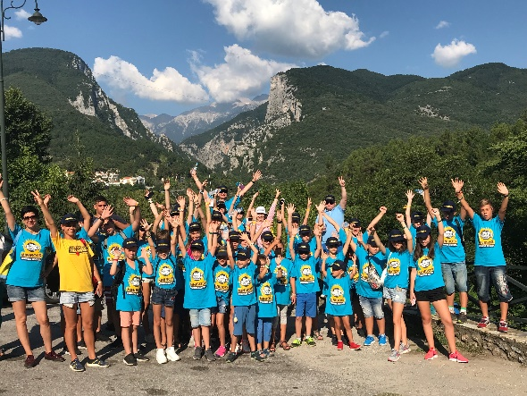 | 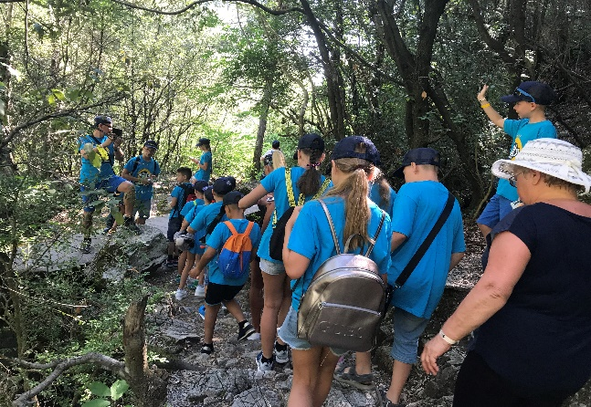

ALL INCLUSIVE PRICE (accommodation, meal, educational & entertaining program, taxes, service fees)

€ 1080 for kid and € 1260 for adult (price is valid until 30.03.2020);

€ 1150 for kid and € 1300 for adult (price is valid until 30.05.2020);

€ 1200 for kid and € 1400 for adult (from 1.06.2020).

• The indicated net prices in euros per person for the entire period;
• In case of double occupancy of adults - an extra charge of 200 euros / each;
• Accommodation in a room with a bathroom, TV, air conditioning, refrigerator;
• For every 15 children - 1 place for the leader / teacher is free.

The price includes:
• Accommodation at the hotel in the hotel;
• ALL Light “buffet” with water, tea and instant juice during meals;
- breakfast: 8:30 - 10:00
- lunch: 12:30 - 14:00
- snack: 16:00 - 16:30 (only for children)
- dinner: 18:30 - 20:30
• Change of bed linen - 1 time for 7 days;
• Hot and cold water in the bathroom – day and night;
• Use of 2 football and volleyball fields;
• Provision of sports equipment (balls for volleyball, football, basketball);
• Use of iron / at the reception /;
• Medical care - 24 hours;
• 24-hour camp guard by specialized services;
• Wi-Fi in the restaurant and beach area;
• Rich educational game and animation program of MINIBOSS with professional English-speaking and Russian-speaking trainers / tutors, etc.

Additional charges:
• Insurance; • Air or bus tickets; • Payment for accompanying children - 50 euro / person;
• Group transfer Thessaloniki-camp-Thessaloniki (min 15 people);
• For accommodation of 2 people per room - extra charge for each adult + 20 euro/day,
• For every 15 children - 1 place for a leader/teacher free of charge.

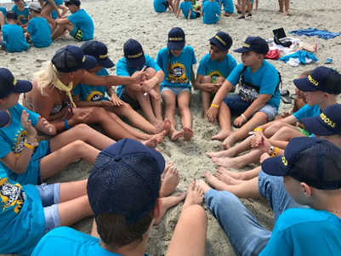 | 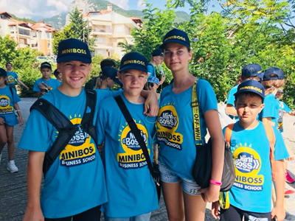 | 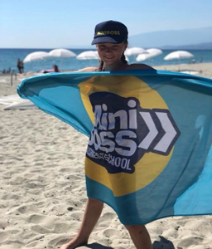

camps.miniboss-school.com

WELCOME TO GREECE!

