DESCRIPTION
CREATIVE BUSINESS FEST of
MINIBOSS BUSINESS SCHOOL

International Education Network MINIBOSS BUSINESS SCHOOL has developed academic know-how in the form of an inspiring educational intensive course “MINIBOSS Creative Business Fest”. This event is held exclusively on vacation as a form of "learning + entertainment". On vacations, knowledge should be gained in portions and immediately applied! For this, a special atmosphere of an educational festival-holiday is created.

“MINIBOSS Creative Business-Fest” is a MINIBOSS BUSINESS SCHOOL educational tool, which contains:
• intensive course (5-7 days) on one of the topics
• games, workshops (implementation) in the form of creative battles,
• mass celebration, show of achievements in science, engineering, entrepreneurship, music, performing, pop or film arts, as well as sporting achievements.
• awards ceremony.

The goal of Business Fest: to develop students' creative thinking that will help them solve complex tasks in life in many ways and invent unique ideas of businesses! AN INNOVATIVE IDEA is 50% of business success!

In a programme:
- creative games;
- teambuilding games;
- business games aimed at the formation of communication within the team, the formation of team tactics, the creation of internal team rules;
- training in the basic principles of TRIZ (Theory of Inventive Problem Solving TIPS);
- solving open tasks;
- creative battles;
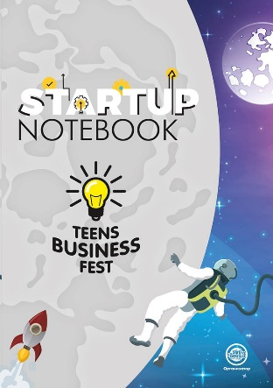
- common large team building with a quest;
- Demonstration of success in the form of a festival.

Possible topics for Business Festivals:
• Science and Business
• TRIZ and invention
• TRIZ and creative ideas
• FAMILY CREATIVE STUDIO
• Art week
• Film Week
• Rhetorical upgrade, etc.

There is a special Business Fest notebook for taking notes.

EXAMPLES:

BUSINESS FEST 2019 «Rhetorical Upgrade»
for children aged 6-14 and youth aged 15+
on winter vacation
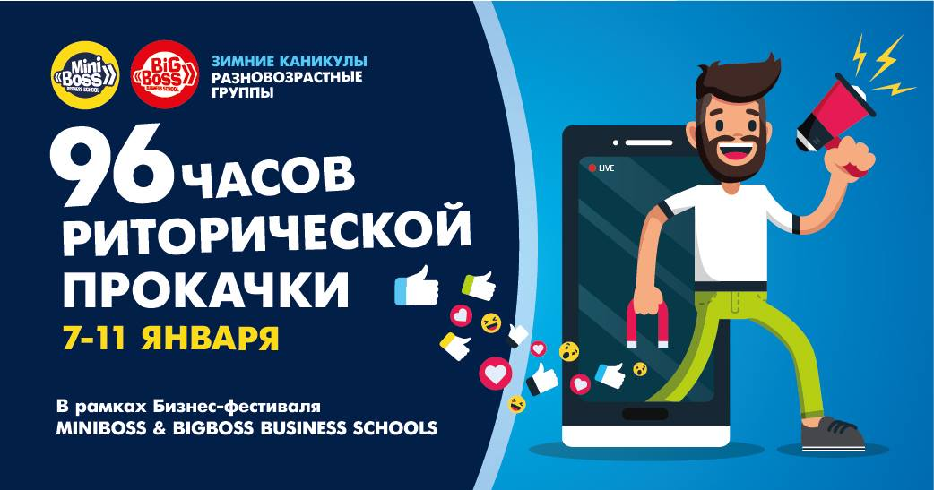

CREATIVE BUSINESS FEST 2019 «TRIZ»
for children aged 6-14
in International business forum in Turkey together with Visotsky Consulting
on spring vacation
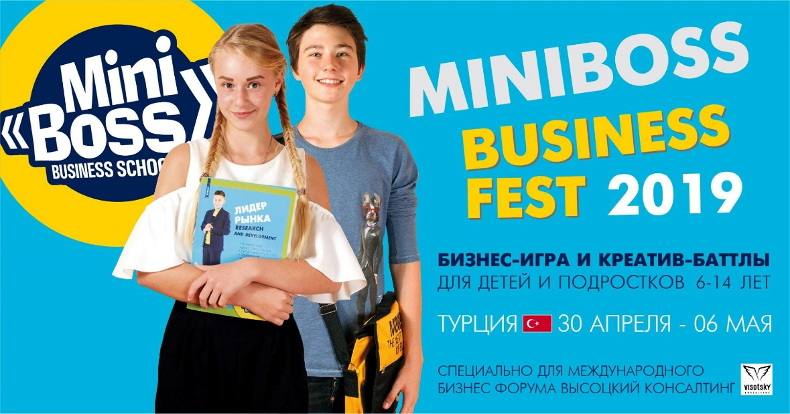

STARTUP FEST 2019 «BUSINESS IDEAS»
for youth (aged 15+)
in International business forum in Turkey together with Visotsky Consulting
on spring vacation

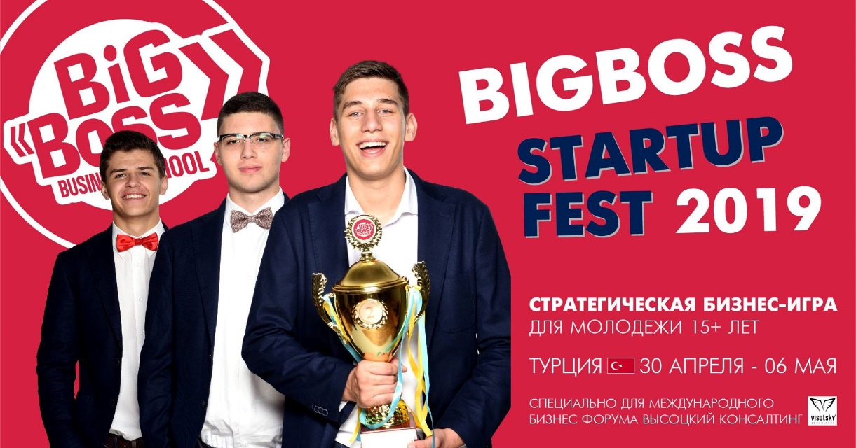

BUSINESS FEST 2018 «FIVE LAWS OF CREATIVITY»
for children aged 6-14 and their parents
on winter vacations
