DESCRIPTION
MINIBOSS BUSINESS INCUBATOR

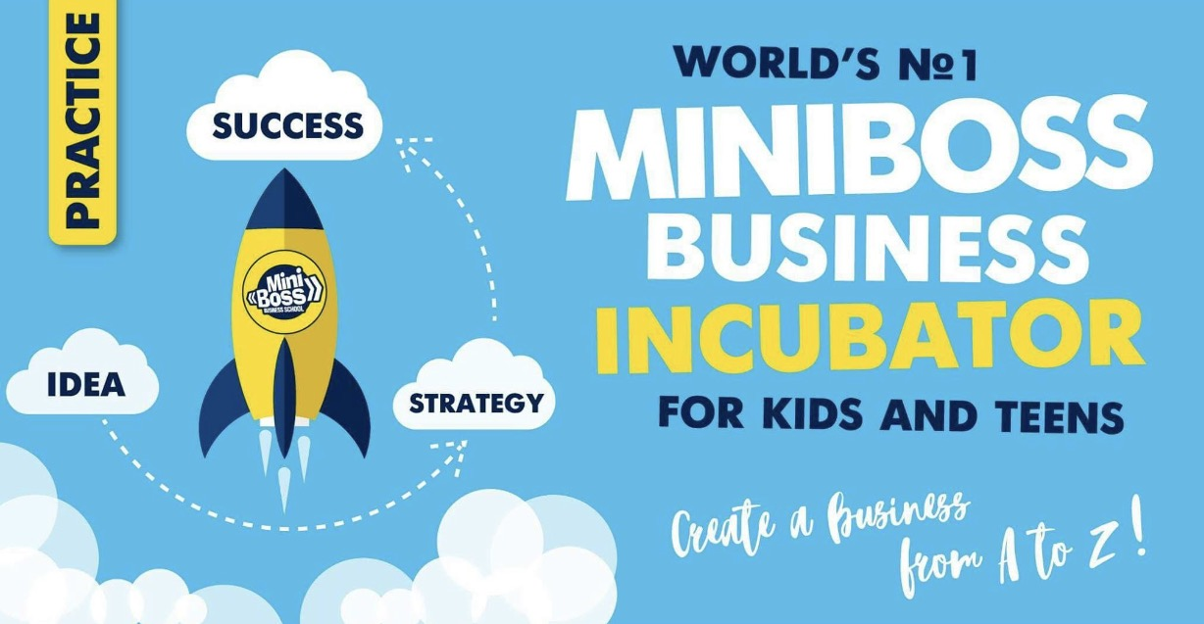

International Education Network MINIBOSS BUSINESS SCHOOL, represented by a group of scientists and entrepreneurs led by Olga and Andrii Azarov, invented the 1st in the world Business Incubator for Children and Teens in 2000.

MINIBOSS PRACTICE AND ITS ELEMENTS

FORMATS OF MANDATORY ANNUAL MINIBOSS WORKSHOPS

MASTER CLASSES | BUSINESS INCUBATOR | SRB FORUM | CHAMPIONSHIP
January-April | January-May | February/March | May/ August

FEW ELEMENTS OF THE MINIBOSS EDUCATIONAL MODEL (International Business Tours and International Business Camps) can only be organized by the Franchiser and offered by the franchisee on behalf of the Franchisor’s Head Office. Franchisees can express in writing their wishes regarding the desired countries and companies to include the latter in the plan of Business tours / festivals / camps. Franchisees do not have the right to organize independently and transport students of MINIBOSS branches to any retreats that are not authorized by the Franchiser in writing and indicated in the general plans.

MINIBOSS TEAMBUILDING -is special game activities (preferably in the fresh air) for solving complex tasks by a team and definition of effective team strategies and the role of each team member.
Teambuilding is the process of recruiting team members and establishing processes in a team to achieve a goal.
See Teambuilding Games in the Pedagogical Course.

MASTER CLASSES for MINIBOSS are systematic (in the 2nd semester) classes at enterprises in the form of business excursions in which business owners familiarize children with a certain type of business (presentation, questions and answers).
See the forms at the end.
MINIBOSS BUSINESS FEST are special educational festivals that include elements of interactive lessons, contests and creative battles, in which a beneficial environment is created for the development of students' divergent creative inventive thinking.

MINIBOSS BUSINESS TOURS are special educational and entertaining trips for young entrepreneurs and their parents to study overseas businesses and culture. All this enriches children and adults, opening up places previously unknown to you. On the MINIBOSS Business Tours we have already visited the enterprises TURKISH AIRLINES, SAMSUNG, BMW, AUDI, PRADA, LUIGY BEVEALUQUA, DUCCATI, FERRARI, Lamborghini, EMIRATS, FLYDUBAI, etc.

MINIBOSS BUSINESS CAMP is a unique summer vacation and development of children with a view to increasing their life potential - “secret techniques” are only in the camp system of the International Education Network MINIBOSS BUSINESS SCHOOL.

MINIBOSS BUSINESS INCUBATOR is a mechanism and system for growing entrepreneurial skills and assisting a MINIBOSS student in preparing a project from A to Z (project management) at all stages of development: from creation of an idea to its commercialization on the basis of «European Bureau for Business Development».

European Bureau for Business Development (EBBD) is the operator that provides services under the BUSINESS INCUBATOR mechanism for the International Education Network MINIBOSS.
Every franchisee can and must create MINIBOSS Business Incubator at its base as an official representative of MINIBOSS.
All technologies for working with children and entrepreneurs based on the “Business Incubator” are the intellectual property of MINIBOSS BUSINESS SCHOOL and are protected by international law.

MINIBOSS BUSINESS INCUBATOR INCLUDES ELEMENTS:
1. ADVISORY COUNCIL OF BUSINESSMEN
(you need to create it from among business owners with a minimum 20 people.)
2. CREATIVE STUDIOS and BUSINESS FESTS (studios of development of divergent thinking and generation of project ideas) under the guidance of teachers,
3. BUSINESS CENTER - leasing (subleasing) of non-residential premises to MINIBOSS business entities (meeting rooms, offices),
4. SRB FORUM (STARTUP FORUM),
5. CONSULTING (directly with entrepreneurs who gave a grant) on the jurisprudence, taxation, planning, lending, accounting, etc.,
6. “REGISTRATION OF THE ENTERPRISE” at the EBBD,
7. ACCOUNTING SUPPORT,
8. LEGAL SUPPORT,
9. POSTAL and SECRETARY SERVICES,
10. AVAILABILITY OF OFFICE EQUIPMENT AND ACCESS TO IT (printer, copier, scanner, telephone PBX, etc.),
11. AVAILABILITY OF INTERNET CHANNEL,
12. PROMOTION OF BUSINESS (professional marketing).

The role of the MINIBOSS Business Incubator in the “ecosystem” of entrepreneurship and venture financing:
• modeling and simplification of the process line of entrepreneurship for academic purposes;
• creation of step-by-step technology for creating projects from A to Z;
• building a team support mechanism during project preparation,
• selection of ambitious startups for funds and preparation of teams to attract investment rounds;
• assistance in the recruiting and management of teams;
• teams are trained simultaneously as a part of the stream (also referred to as composition, set). Constant communication facilitates the exchange of experience and mutual support;
• seed financing at the Startup Forum.
Business incubation programs are limited to several months, during which teams are trained in areas close to entrepreneurship, communicate with well-known entrepreneurs, investors and niche specialists, work with mentors.

HISTORY OF BUSINESS INCUBATORS
The first prototypes of business incubators appeared in the UK in the middle of XX century.
The first Business Incubator in the modern sense of the word was founded in 1959 in the United States. Joseph Mancuso bought a warehouse near the factory in the city of Batavia and founded the first incubator in America - the Batavia Industrial Center. His goal was to create new jobs in the city with an economic depression.
In 1985, there were about 70 business incubators in the world, in 1992 there were 470 incubators, in 1995 there were 1100 incubators united in the National Association of Business Incubators. The largest number of business incubators was created in the United States, helped by the need to revitalize degraded urban centers and regions, to promote innovation and entrepreneurial activity in universities, and to create attractive conditions for private investors.
In many countries, incubation programs are funded from national or municipal budgets as part of an overall economic development strategy. For example, the United States, Great Britain, and Poland are the leaders in state incubation programs. It is not surprising why entrepreneurship is so developed in these countries and the economy is so strong.
In the United States today, most incubation programs are independent and funded by communities and projects. The Department of Economic Development of USA is often the source of funds for opening incubation programs, but as soon as a program starts and starts functioning, it usually stops receiving federal funding. The rent and / or customer contributions make up 59% of the income of the incubators, 18% comes from fees for services or grants, and 15% comes from cash subsidies.
In 2000, for the first time in history, Olga and Andrii Azarov created a Business Incubator for children and teenagers on the basis of the International Education Network MINIBOSS BUSINESS SCHOOL, which had more than 5,000 young entrepreneurs’ alumni by 2019.

SILICON VALLEY is the south-western part of the San Francisco Bay Arey in Northern California (USA), characterized by a high density of high-tech companies associated with the development and production of computers and their components, especially microprocessors, as well as software, mobile communication devices, biotechnology, etc.
The original English name for the valley Silicon Valley is derived from the use of silicon as a semiconductor in the manufacture of semiconductor devices (diodes, transistors, microcircuits). The history of the valley as a technology center began with this industry. This name was first used on January 11, 1971 by journalist Don Hefler, when he began to publish a series of articles titled "Silicon Valley USA".

BUSINESS ACCELERATOR (English startup or seed accelerator, literally “accelerator”) is a social institution supporting start-ups (both institutions and companies' intensive development programs organized by them) via mentoring, training, financial and expert support in exchange for a share in the company’s capital.
The business accelerator model was formed on the basis of the experience gained by entrepreneurs and investors during the dotcom boom. The market practice of that time assumed large investments in individual companies - and it was the principle that start-up incubators for companies in the sphere of information technology existed in the late 1990s. The crisis of technology companies has demonstrated the failure of this model, and the financial losses of the incubators brought them the sarcastic name "waste incinerators").

With the restoration of venture capitalists' interest in the Internet market, a model has been formed that takes into account the growth patterns of startups from this industry. Y Combinator, discovered by Paul Graham, Trevor Blackwell, Robert Morris and Jessica Livingston in Boston in 2005, became a pioneer among accelerators. Instead of the long-term "incubation" of projects, Y Combinator offered three-month group training programs and small seed investments.
The first European accelerator, the London-based Seedcamp, began work in 2007, and by 2013 their number reached 50. A research of the startup support industry in Europe, conducted in 2014, demonstrated activity commensurate with the American start-up ecosystem.
The first European accelerator for high school students and young people was International Education Network BigBoss Business School, which systematized the practices of world-class accelerators and added the tools of intensive development via challenges, Crash Tests, business internships to the general concept.
According to various estimates, by 2019, up to 450 accelerators were operating in the world.

BUSINESS ANGEL is a private venture investor, philanthropist, who provides financial and expert support for startups in the early stages of development.
Historically, business angels are the main source of external financing for new companies with the potential for rapid growth. They help startups to move beyond the stage when the volume of resources required for development exceeds the capacity of the founders, but it is not large enough to interest an investment fund. Angel can invest not only in the finished project, but also in the idea that it is impossible for an institutional investor.
The concept of "angel" was formed in the theater environment of New York at the beginning of the XX century. In the Theater District around Broadway, the wealthy theater fans who invested in new plays were called "angels". They were attracted by the patronage of art and close acquaintance with eminent actors and directors. Investments were risky, the “angel” made a profit only if the play was successful. For private investors, this term was first used by William Wetzel, a professor at the University of New Hampshire in 1978. This feature was provided to wealthy men with entrepreneurial and managerial experience, who non-publicly invested in local companies in the early stages of development.
Business angels existed long before the term appeared. For example, in 1874, Thomas Sanders and Gardiner Green Hubbard became investors of the telephone company Alexander Bell, and a few years later they made a successful “exit” from a successful project. In 1878, entrepreneurs John Pierpont Morgan and Spencer Trask funded Thomas Edison's development in the field of electricity. Henry Ford attracted 40 thousand dollars from five private investors to start the company in 1903. Stanford University’s Vice President Frederick Terman invested $ 538 of personal funds in the development of the oscillator of William Hewlett and David Packard.
Business angels have played a role in the formation of many modern corporations. Richard Kramlich was the first who invested $ 22,500 into the Steve Jobs and Steve Wozniak’s venture, the future Apple corporation. Anita Roddick, the founder of Body Shop, was unable to get a loan to open a second store in 1976, and car dealer Ian McGlinn invested £ 4,000 in her business in exchange for half of the company. In 1995, Jeff Bezos attracted $ 981,000 in investment in Amazon from 20 angel investors. The founder of Sun Microsystems, Andy Bechtolsheim and Stanford University professor David Cheriton, who invested $ 100,000 in the company, became the first investors of Google. Microsoft, Dell and Intel received support from business angels at the very beginning of their development.
Angelic investments are often described as “smart money”: angels are more likely to support projects in which they can apply their own experience. Personal engagement and expertise is the fundamental difference between business angels and other private investors. Among active business angels there are many entrepreneurs who have attracted external financing in their own projects.

