EUROPEAN ASSOCIATION
FOR BUSINESS DEVELOPMENT
EUROPE COMMITTEE: www.eabd.org
Call:______________
Business Tour Director: __________
22 of August 2018

Official Delegate
Company Name
Country Name

Dear Official Delegate:
On behalf of the EUROPEAN ASSOCIATION for BUSINESS DEVELOPMENT, we invite you to participate in the BUSINESS TOUR TO FRANCE 2018.

This is a special invitation to you to participate in the BUSINESS TOUR TO FRANCE 2018 f, which will take place 22-18 October 2018 in Paris, France.

Well-known entrepreneurs, top managers, government officials, and students of International Education Network MINIBOSS & BIGBOSS Business School meet annually on business tours in different countries to study the business environment and the culture of the given countries on the example of the most famous brands of this country.
The tour program and a list of excursions are attached below.

As one of the official MINIBOSS BUSINESS SCHOOL delegates from (country here), we are very pleased to welcome you at this educational event. Please use this letter for visa purposes.

International Education Network MINIBOSS BUSINESS SCHOOL mission is to help create the next generation of entrepreneurial leaders whose innovations address our world’s major unmet needs.

HOTELS FOR ACCOMMODATION OF OFFICIAL MEMBERS OF DELEGATIONS:
https://www.adagio-city.com/gb/hotel-6797-aparthotel-adagio-porte-de-versailles/index.shtml

Each participating country delegations are responsible for making their own travel and transportation arrangements to Paris, France.

If you have any questions, please don’t hesitate to contact me.

Sincerely,
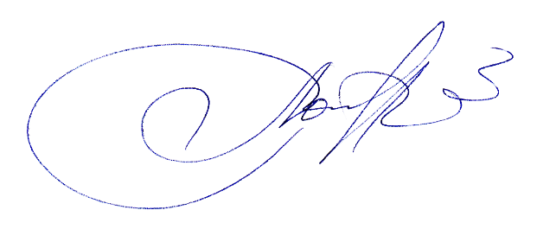
Business Tour Director: Olga Azarova
olgaazarova100@gmail.com

BUSINESS TOUR TO FRANCE
October 22-28, 2018
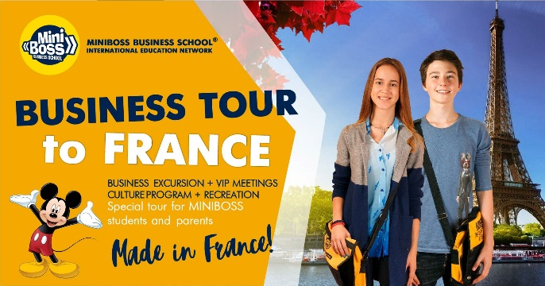
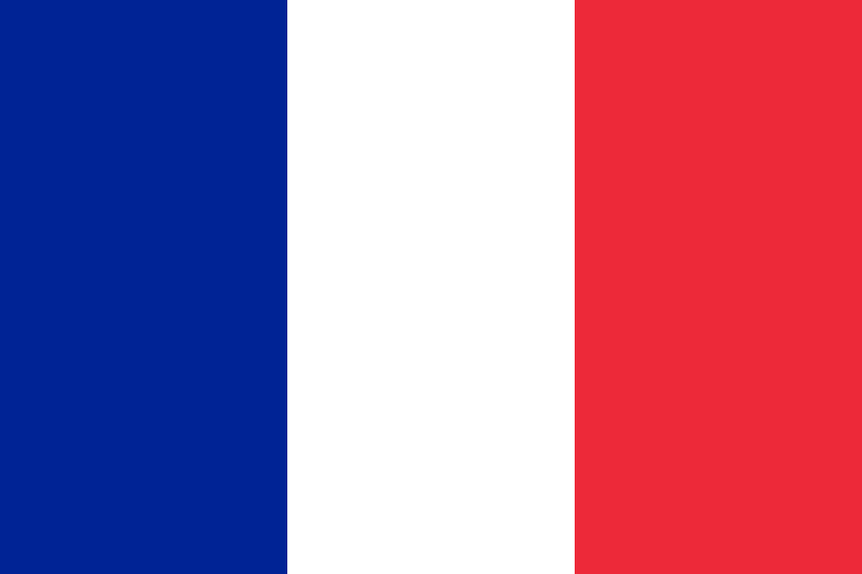
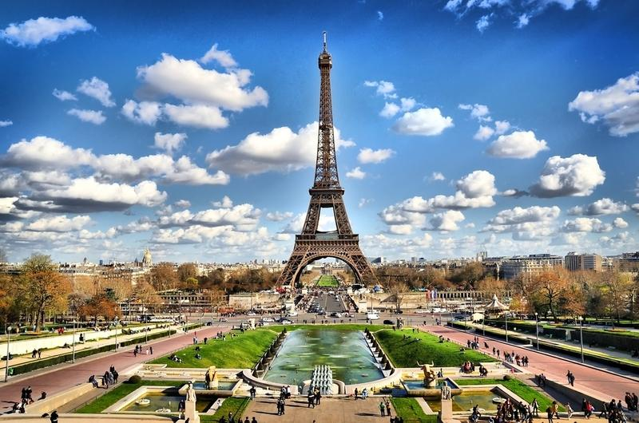

Participants: entrepreneurs and top managers, state agents, deputies, Members of Business Associations, members of the Club of Successful Women, students of the MINIBOSS and BIGBOSS Business Schools!

BUSINESS TOUR GOAL: study of the European business environment and specific businesses; participation in business networking; visiting business excursions and cultural events.

ORGANIZER: European Association for Business Development (EARB) (www.eabd.org) with the International Educational Network MINIBOSS & BIGBOSS BUSINESS SCHOOL
(www.miniboss-school.com, www.bigboss-school.com).
+38-093-009-40-40, +38-093-305-38-88, +38-093-303-00-99

PROGRAM 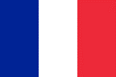 ПРОГРАММА
Day 1st Monday
Arrival in Paris. BUSINESS EXCURSION # 1 in L'AÉROPORT PARIS CHARLES DE GAULLE
Excursion around the airport Charles de Gaulle.
Accompanied by a guide, on an electric car you will visit the metropolis of the airport, a cargo area (more than 2 billion tons of cargo per year), terminals (more than 60 million passengers), Roissypôle business zone, technical zones and control towers.
You will witness a take-off or landing every 30 seconds: 1500 landings and take-offs a day!
The tour is conducted by the airport top-management, pilots and aviation specialists who will share their experience with you. Located 25 km north of Paris, Paris-Charles-de-Gaulle Airport is located on 3257 hectares, more than half the territory of Roissy.

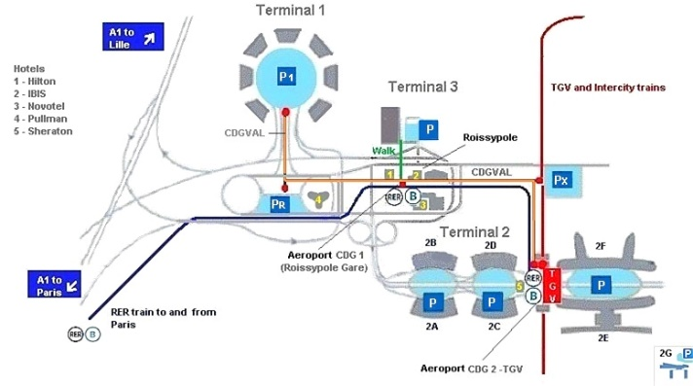
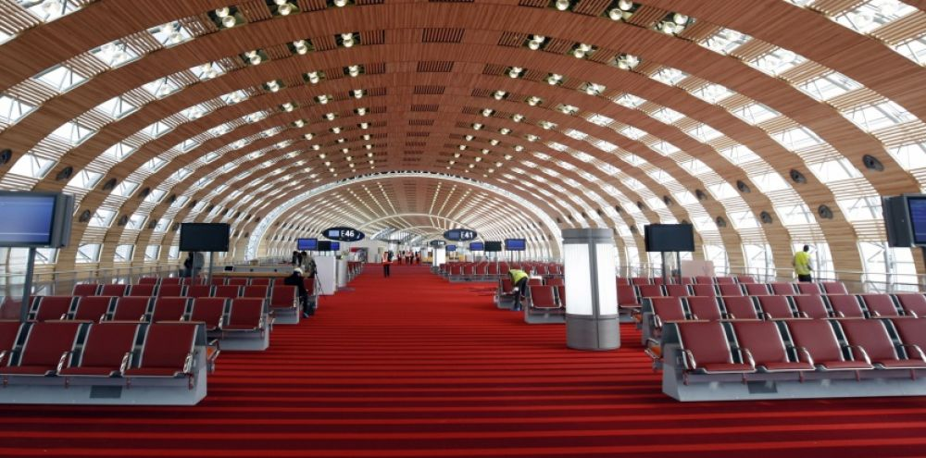
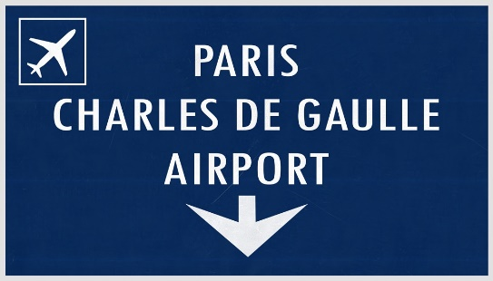
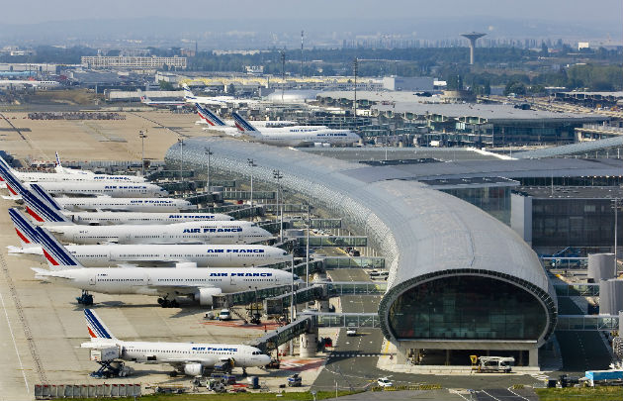
Check in at the hotel, evening walk.

Day 2nd Tuesday

A BUSINESS EXCURSION # 2 to the plant and museum LE CONSERVATOIRE CITROËN.

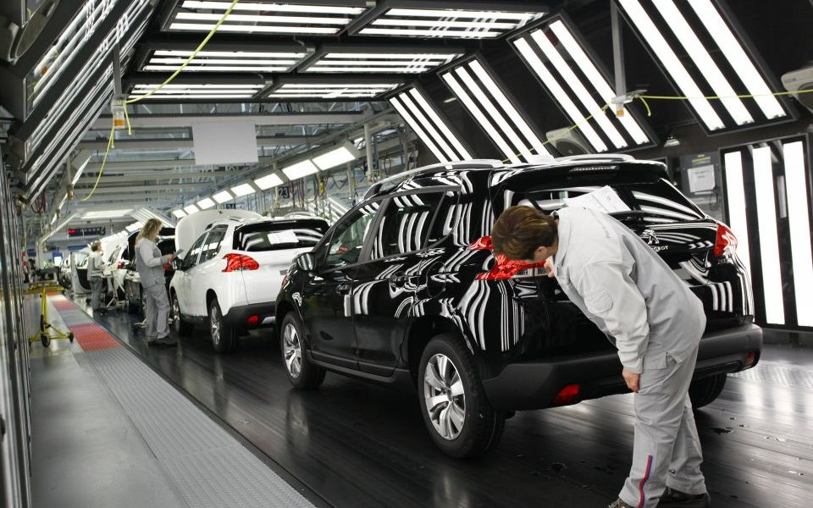

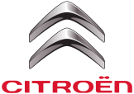

Citroën is a French automotive company, founded in 1919 by André Citroën. Since 1976, it has become part of the PSA Peugeot Citroën group, headquartered on Fructidor Street in Paris. Initially, the manufacturer of low-cost mass-consumption vehicles with a relatively simple design, Citroën in 1934 launched the revolutionary and very successful Traction Avant model - the first serial front-wheel-drive passenger car.

A BUSINESS EXCURSION # 3 to the LES ATELIERS DE LA MANUFACTURE DES GOBELINS
Manufacture of tapestries. Since 1900, dedicated to the design and decoration of official palaces in tapestries and carpets, The Gobelins, Beauvais and Savonnerie factories have produced more than 2,000 masterpieces in the public collections of Mobilier National. In this Parisian manufactory, you will see how the family business with 118 years of history works.

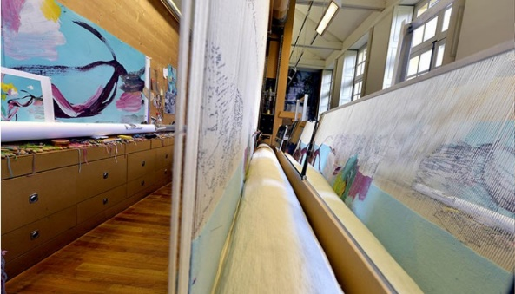
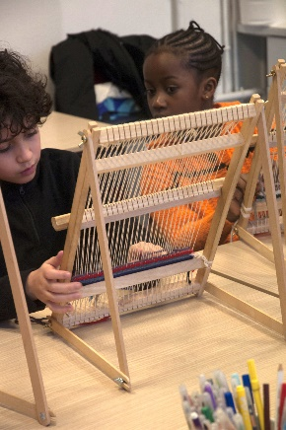

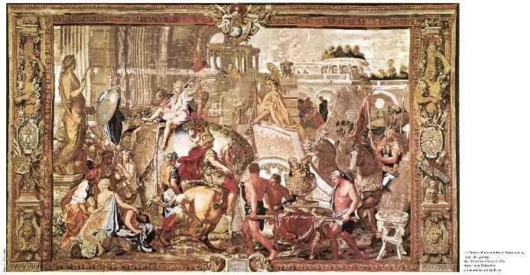

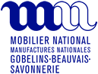

Day 3rd Wednesday

A CULTURAL SIGHTSEEING EXCURSION # 4 OF PARIS, Eiffel Tower, Champs Elysees, Arc de Triumph, Louvre.

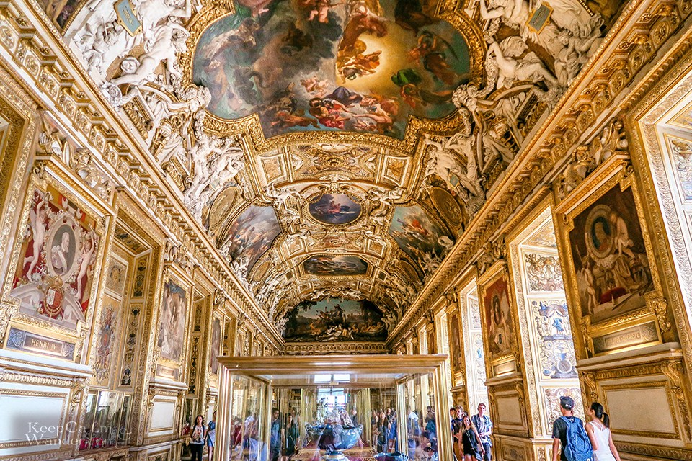
A BUSINESS EXCURSION # 5 - Meeting in the Chamber of Commerce and Industry (waiting for confirmation), presentation of business in France.

The Louvre Museum is the world's largest art museum in Paris, France. A central landmark of the city, it is located on the Right Bank of the Seine in the city's 1st arrondissement (district or ward). Approximately 38,000 objects from prehistory to the 21st century are exhibited over an area of 160,735 square metres. In 2017, the Louvre was the world's most visited art museum, receiving 8.1 million visitors.
The museum is housed in the Louvre Palace, originally built as the Louvre castle in the late 12th to 13th century under Philip II.
The collection is divided among eight curatorial departments: Egyptian Antiquities; Near Eastern Antiquities; Greek, Etruscan and Roman Antiquities; Islamic Art; Sculpture; Decorative Arts; Paintings; Prints and Drawings.

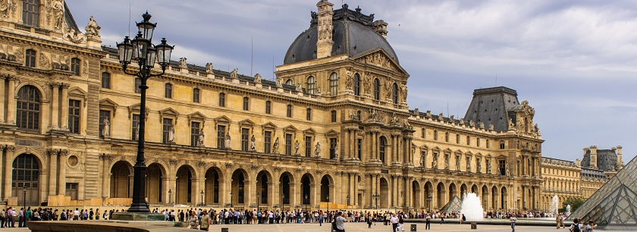

Day 4th Thursday
You can choose one of the suggested excursions.

A BUSINESS EXCURSION # 6 to the DISNEYLAND. Entertainment day in Disneyland.
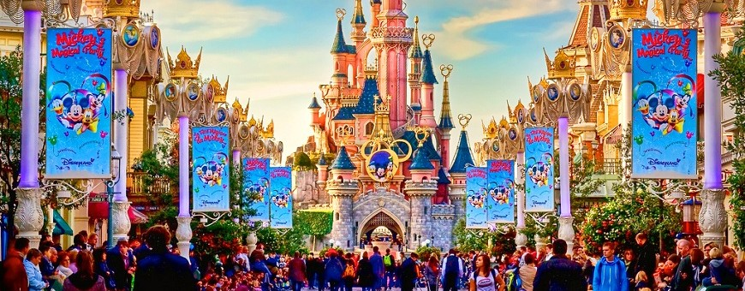
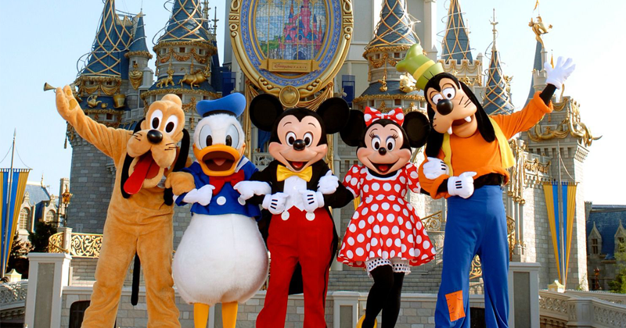

А BUSINESS EXCURSION # 7 to the Les techniques de fabrication de la Manufacture nationale DE SEVRES. Production technologies of de Sèvres. The opening of the production of Sevres porcelain: an exhibition hall with video projections will allow you to understand the technology of making famous porcelain, from making a dough to decorating through a form that has been in operation since the 18th century. Visiting two ateliers will give you the opportunity to admire the know-how of the masters.
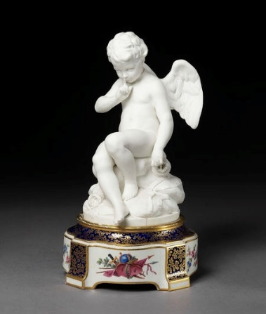
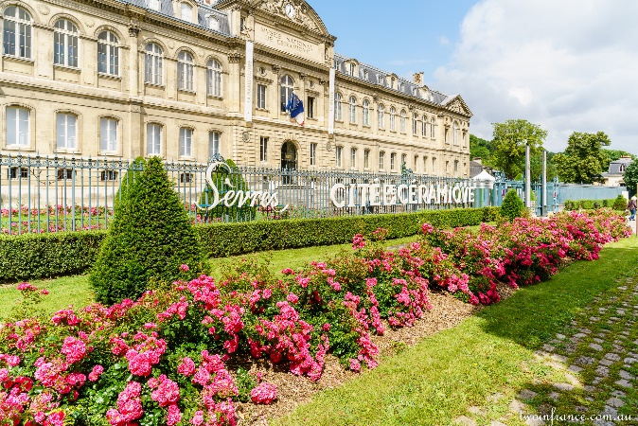
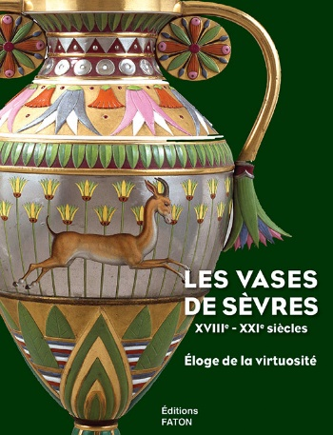

Day 5th Friday / День 5й, пятница
Check out from the hotel. Moving to Normandy.

NORMANDY! А BUSINESS EXCURSION # 8 to the OYSTERS FARM.
The city of Cancale is the world capital of oysters. Today there are 400 hectares of oyster plantations, and out of 5,000 people in the town, more than half of them either bred mollusks or sell them. Oysters are grown in special bags of steel mesh. The process is quite long: the adult, the best oyster, - 4-year, 100-gram. Molluscs from Cancale are transported to restaurants around the world.

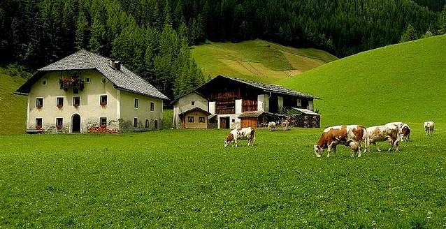
A CULTURAL EXCURSION # 9 to the famous fortress island of Mont-Saint-Michel, which is one of the main attractions of France.
Overnight at the hotel in Normandy.
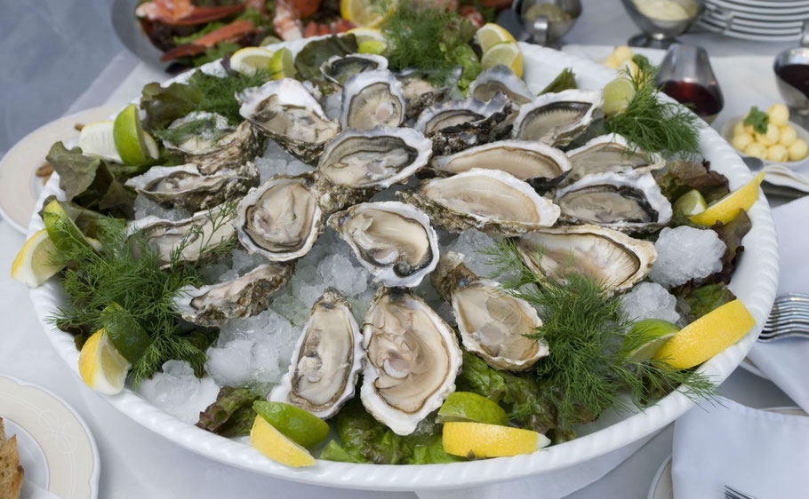

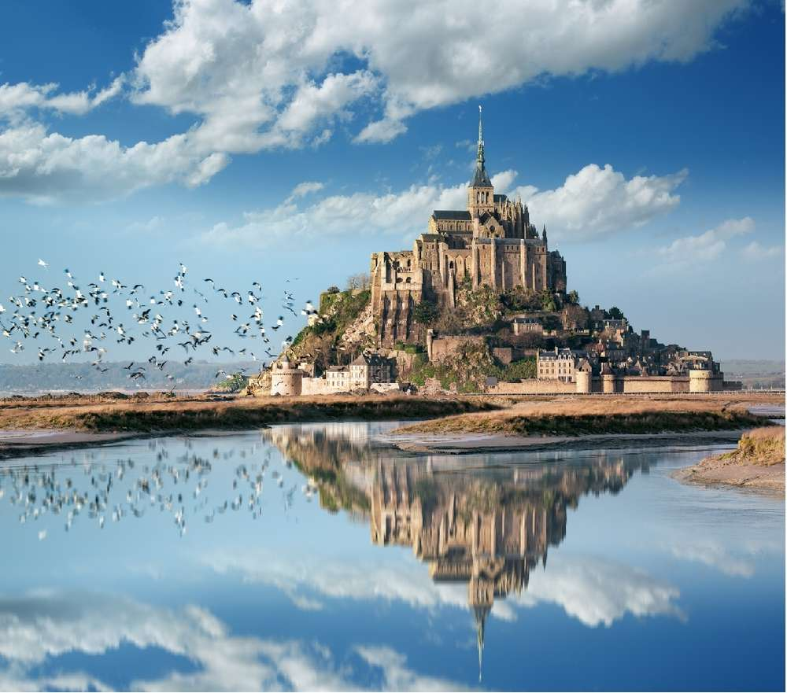

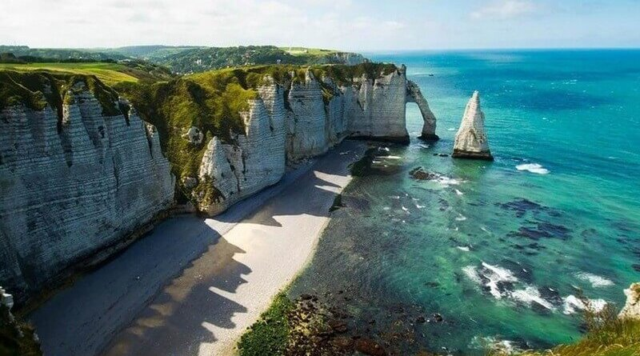

Day 6th Saturday
Check out from the hotel.

A CULTURAL EXCURSION # 10 to the famous city Saint Malo, which is one of the main attractions of France.

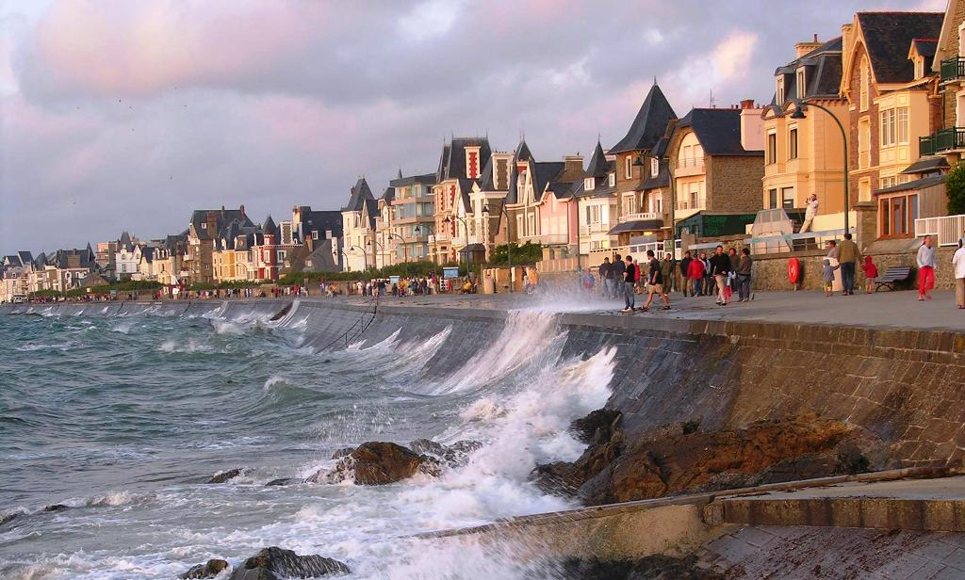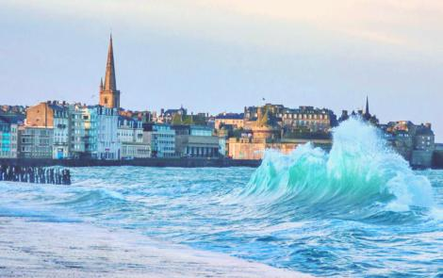

If time still remains, then we recommend excursion # 11
BUSINESS EXCURSION TO THE LA CITÉ DES SCIENCES ET DE L'INDUSTRIE
The Cité des Sciences et de l'Industrie is the biggest science museum in Europe.
Attractions include a planetarium, a submarine (the Argonaute), an IMAX theatre (La Géode) and special areas for children and teenagers. The most notable features of the "bioclimatic facade" facing the park are Les Serres – three greenhouse spaces each 32 metres high, 32 metres wide and 8 metres deep. The facades of Les Serres were the first structural glass walls to be constructed without framing or supporting fins.

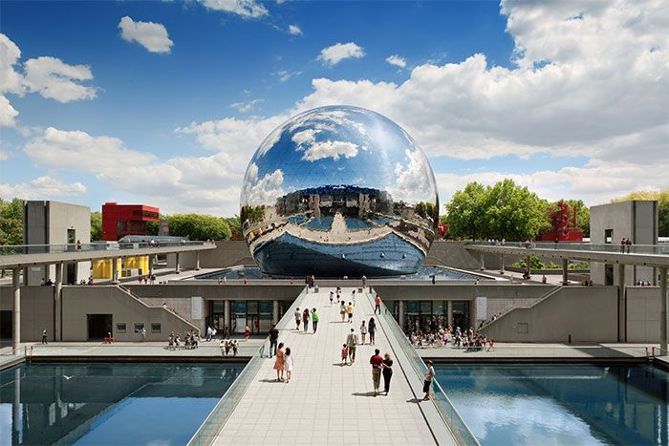

Day 7th Sunday / День 7й, воскресенье.
Check-in to the hotel. Check-out from the hotel. Departure.

PRICE: € 888/ person
The price includes:
- the cost of living in a 2-bed room in hotels 4-3 stars,
- breakfasts,
- cost of a group transfer (from 20 people),
- the cost of a sightseeing bus and all cultural excursions,
- cost of services of guides,
- the cost of business excursions to plants and farms,
- printed Business tour program,
- Tour souvenirs.

Must be paid additionally:
- Organization fee - € 200 / person (€ 100 per children),
- air tickets,
- insurance,
- cost of excursions # 7, 11, tickets to Disneyland and The Louvre,
- supervision payment - € 50 for every child.

The program is preliminary, the program can be changed.

OFFICIAL REPRESENTATIVES - CALL US FOR BOOKING:
+ 38-093-303-00-99

The PHILIPPINES: +63-3333-811-61
INDONESIA: 021-300-426, 08-15-182-20-21
THAILAND: 026-563-159

www.miniboss-school.com

