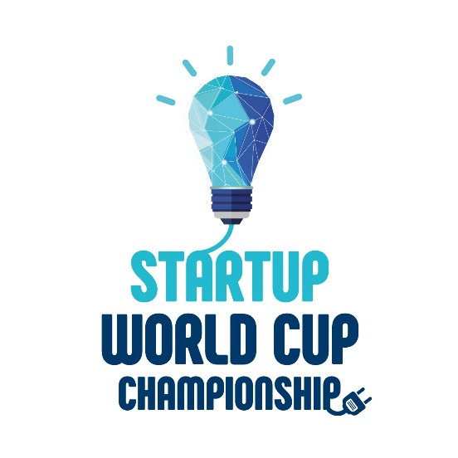
STARTUP WORLD CUP
CHAMPIONSHIP
FOR CHILDREN AND YOUTH

STARTUP WORLD CUP CHAMPIONSHIPS is the main world’s annual event for young entrepreneurs, which brings together national elites from different countries of the world to get acquainted, communicate and determine the best startups of the year.

STARTUP WORLD CUP CHAMPIONSHIPS have been held since 2000 under the auspices of the International Educational Network MINIBOSS & BIGBOSS BUSINESS SCHOOL (The United Kingdom).
Official website: www.StartupWorldCup.biz

MISSION: global unity and cooperation for the benefit of the world; building global communication bridges and cooperation between young national elites.

LEAGUES
AT THE STARTUPS WORLD CUP CHAMPIONSHIP, students present their start-ups in TWO AGE LEAGUES:
- MINIBOSS Junior League (children and teenagers 6-14),
- BIGBOSS Senior league (youth 15+).

CATEGORIES/ NOMINATIONS
The jury assesses startups in two categories:
- INNOVATIVE ENTREPRENEURSHIP
SIFE - Startups in innovative free entrepreneurship
These entrepreneurs start a company knowing from day one that their vision could change the world. Innovators are the types of entrepreneurs who come up with completely new ideas and turn them into viable businesses.
In most cases, these entrepreneurs change the way people think about and do things. Such entrepreneurs tend to be extremely passionate and obsessive, deriving their motivation from the unique nature of their business idea.
Innovative entrepreneurs also find new ways to market their products by choosing product differentiation strategies that make their company stand out from the crowd. Moreover, sometimes it is not just standing out from the crowd but also actually creating a new crowd.
They hire the best and the brightest. Their job is to search for a repeatable and scalable business model. When they find it, their focus on scale requires even more venture capital to fuel rapid expansion.
Innovators such as Steve Jobs (Apple), Larry Page (Google), Richard Branson (Virgin Group), Ilon Musk (Tesla), and Bill Gates (Microsoft) are a prime example of innovative entrepreneurship.
Innovative startups are always commercial (for-profit).

- SOCIAL ENTREPRENEURSHIP
SAGE - Startups for the advancement of the global environment
Social entrepreneurs are innovators who focus on creating products and services that solve social needs and problems. However, unlike scalable startups their goal is to make the world a better place, not to take market share or to create to wealth for the founders. They may be nonprofit, for-profit, or hybrid.

The well-known social innovators such as Muhammad Yunus (Grameen Bank, 2006 Nobel Peace Prize winner, microcredit pioneer), Bill Drayton (Ashoka, which provides search and support for social entrepreneurs around the world), Rachel Braten (Yoga Girl and online channel oneoeight.tv), Shiz Shaheed (ambassador of the Malala Foundation, helps empower women and girls by promoting and expanding access to education), Bleu Mr. Mikoski (TOMS Shoes, a shoe company that donates one pair of shoes for each sold to support water) are a prime example of social entrepreneurship.
Social startups can be non-profit, commercial (for-profit) or hybrid.

JUDGING CRITERIA
Judging Criteria for SIFE category:
1. Innovation (novelty)
2. Profitability
3. Scaling
4. Media coverage
5. Quality Q & A period.

Judging Criteria for SAGE category:
1. Social utility of the idea (relevance)
2. Social resources (stakeholders),
3. Social impact (scaling)
4. Media coverage
5. Quality Q & A period.

PARTICIPANTS OF THE CHAMPIONSHIP:
- students,
- teachers,
- parents,
- entrepreneurs as members of the MINIBOSS & BIGBOSS Global Business Council,
- representatives of state and local government from all national delegations,
- representatives of sponsoring companies,
- representatives of mass media and social media.

FIVE LEVELS OF PREPARATION:
Young leaders undergo a serious training system before the participation at Startup World Championship:

1. BUSINESS EDUCATION
For a whole year on weekends students of MINIBOSS and BIGBOSS Business Schools study the theory and practice of business, psychology, innovative entrepreneurship, develop their talents, prepare their own startups, according to the unique academic game method of MINIBOSS & BIGBOSS BUSINESS SCHOOLS, which is registered in the UN - World Intellectual Property Organization (Switzerland) as a unique intellectual property and global copyright.
Enroll in MINIBOSS Business School (for children 6-14 y.o.)
www.miniboss-school.com
Enroll in BIGBOSS Business School (for youth 15-25 y.o.)
www.bigboss-school.com

2. BUSINESS INCUBATOR: TEAM & IDEA
After the theory, students start to practice in the MINIBOSS & BIGBOSS Business Incubator, create teams, generate innovative ideas of ​​a startup, and develop projects from A to Z under the management of experienced practicing teachers and famous entrepreneurs-mentors.

3. STARTUP FORUM
The next stage of preparation is the presentation of projects at the STARTUP FORUM, where well known entrepreneurs of local business council (members of the Global Businessmen Council of MINIBOSS & BIGBOSS BUSINESS SCHOOLS) issue grants to young entrepreneurs for the implementation of their projects.

4. STARTUP NATIONAL/ FEDERAL CHAMPIONSHIP
After the implementation of projects, teams participate in the Startup National/ Federal Championships and present their startups. The Champions receive Awards, Diplomas and the privilege to go straight to the World Cup final.

5. STARTUP WORLD CUP CHAMPIONSHIP
All students/teams have the right and commitment as an academic standard to participate in the StartUp World Cup Championship every year. Moreover, the World Championship shows the degree of students’ development in entrepreneurship and the strength of their character as an academic result of the year, therefore participation in the World Championships is a mandatory criterion for obtaining an International Certificate and Diploma of MINIBOSS & BIGBOSS BUSINESS SCHOOLS.
Participation in StartUp World Cup Championship and in cultural, educational and leadership events of the International Leadership Camp is a biggest global event of the year for young leader and well-known entrepreneurs as social responsible businesspersons as global business elite.
Startup World Cup Championship as the main event of the year for global business elite is held annually in July-August. All accredited participants - MINIBOSS & BIGBOSS BUSINESS SCHOOLS students - come to Startup World Cup Championship and participate in the qualifying round and the final round. National Champions have the privilege to go straight to the World Cup final.
The international composition of the jury determines the best ideas that have changed the world, the best business projects and social projects and awards the winners with Champions CUP, MEDALS, DIPLOMAS and SPECIAL PRINCIPLES.

STARTUP WORLD CUP CHAMPIONSHIP

OFFLINE PROGRAM

1st day - WELCOME DAY

2nd day – GLOBAL FRIENDS’ DAY

3rd day - GLOBAL FAMILY TEAMBUILDING

COUNTRIES’ DAY - the Cultural Show “PARADE OF COUNTRIES”

4th day - BIGBOSS GLOBAL BUSINESS FORUM

GLOBAL BUSINESS FORUM & NETWORKING.

5th day – STARTUP WORLD CUP CHAMPIONSHIP: QUALIFYING & FINAL ROUND

6th day - Gala Dinner and Solemn Awarding of the winners and participants.

7th day - DEPARTURE.

STARTUP WORLD CUP CHAMPIONSHIP

ONLINE PROGRAM

1st day - student registration

2nd day - registration of Jury members

3rd day - WORLD CHAMPIONSHIP QUALIFYING ROUND
Performances of league teams in the SIFE nomination.

4th day - WORLD CHAMPIONSHIP QUALIFYING ROUND
Performances of league teams in the SAGE nomination.

5th day - BIGBOSS GLOBAL BUSINESS FORUM

GLOBAL BUSINESS FORUM AND NETWORKING - speeches of famous entrepreneurs from different countries - members of the Global Business Council MINIBOSS & BIGBOSS BUSINESS SCHOOLS.

6th day - STARTUP WORLD CUP CHAMPIONSHIP FINAL
Performances of teams in leagues and in nominations.

Winners Announcement. Awarding. UN special prizes.

7th day - OFFICIAL DISCLAIMER OF THE WORLD CHAMPIONSHIP RESULTS ON THE OFFICIAL WEBSITE AND MEDIA.

Official information about the winners will be provided on the main website of the World Cup, as well as sites of media partners.

ACADEMIC REQUIREMENTS
- Championships are one of the important and mandatory educational elements of the academic system - final part of each educational course.

- The required elements to obtain an International Certificate and Diploma of MINIBOSS & BIGBOSS BUSINESS SCHOOLS are:
  - completion of the full academic program (118 academic hours of a course),
  - participation in the Startup Forum,
  - participation in Startup National/ Federal Championship,
  - Participation in Startup World Cup Championship and International Camp.

- International Certificates and Diplomas are issued after the World Championship at the Gala awarding ceremony.

TEAM QUALIFICATIONS
- The team must have no more than 6 participants;

- Teams may consist of students of different ages / courses;

- Participants must be valid students of the accredited MINIBOSS and BIGBOSS Business Schools or representatives of other schools-partners;

- Participants who are not students of partner schools can participate in the championship in the OPEN LEAGUE with a registration fee for each team (1000 euro / team); Students of partner schools - MINIBOSS & BIGBOSS BUSINESS SCHOOLS pay a preferential registration fee (50 euros / person / one championship), which is included in the cost of their training (Price package No. 2 and No. 3).

- All students/ teams have the right and mandatory requirement to take part in the STARTUP WORLD CUP CHAMPIONSHIP for obtaining an International Certificate;

- National Champions have the right and privilege to go straight to the final of the Startup World Cup Championship without a qualifying round;

- Each team must have a teacher-curator who will provide training in an academic program and lead the team up to the qualifying round or final;

- Each team must have a mentor (member of the Global Businessmen Council of MINIBOSS & BIGBOSS BUSINESS SCHOOLS), which will provide business consulting up to the final;

- Victory and any other special awards are collective result and property;

- Each member of the winning team receives a MEDAL and a personal certificate confirming level of achievement in the team victory;

- Each member of the winning team receives an additional certificate “PRIDE OF THE SCHOOL” for additional encouragement on a formal lineup on behalf of MINIBOSS & BIGBOSS BUSINESS SCHOOLS for submission to public schools / gymnasiums / lyceums, where the child studies.

- For each member of the winning team get a petition to the City Mayor / Governor / President of the country for giving credentials and awards to those students who have honorably represented their country at Startup World Cup Championship.

RULES OF COMPETITIONS
- STARTUP WORLD CUP CHAMPIONSHIP language is English;

- Each team prepare and submit a 3-minute presentation of the startup to the jury members;

- Any slides with presentations (and / or other presentation materials) must be provided to the organizers in 14 days before the start of the competition through the teachers-curators. Each team must do technical checkup a day before presentation (in offline championship);

- Teams must present at the World Championship evidence of a successful project:
  - goods in realia,
  - description of the implemented startup in the form of Annual Report (no more than 4 pages of printed version, A4 format),
  - description of the implemented startup in the form of oral presentation,
  - links to websites and social media
  - any other evidence.

- After the presentation there will be a 2-minute period during which judges can ask questions;

- Each nomination has its own criteria for evaluation;

- After the performance of all the teams the judges' points will be calculated to determine the finalists;

- World Championship winners receive various types of awards.

JUDGMENT
- An entrepreneur, a top manager of a company, a representative of a sponsor company, a representative of local municipal authorities or state government may become a member of STARTUP WORLD CUP CHAMPIONSHIP jury;

- Each national delegation may submit to the jury not less than 2 and not more than 30 entrepreneurs;

- A Registration fee (200 €) for participating in the STARTUP WORLD CUP CHAMPIONSHIP panel of judges and a fee (100 euros) for participating in the Country's Championships are mandatory for each member of the jury and demonstrate their readiness to support the new generation of world leaders and socio-economic transformations in the world. Each jury member can express his social responsibility and allocate more than 200 euros to the prize monetary fund to support a new generation of entrepreneurs or become an official sponsor of the World Championship. Information about each member of the jury of the Country’s and World Championship will be published on the official website;

4. Contributions to the fund go to the event organization and distribution between the winning teams in a proportion corresponding to the winning places;

5. The PRIZE MONETARY FUND of the World Cup is open - all names and amounts entered by the jury members will be published on the Championship website (www.StartupWordCup.biz), as well as on the sites of the main educational partners - the International Educational Network MINIBOSS BUSINESS SCHOOL and BIGBOSS BUSINESS SCHOOL;

6. Before proceeding with the judging, all members of the jury will go through official registration (with the payment of a registration fee) and will be informed about the evaluation criteria for each nomination, as well as gain the right to act as speakers at the BIGBOSS GLOBAL BUSINESS FORUM;

7. Each member of the jury signs an oath on the objectivity of international refereeing;

8.Each jury member receives a diploma.

TYPES OF AWARDS:

- BEST BUSINESS STARTUP/ SIFE Award / Startups in an innovative free entrepreneurship;

- BEST SOCIAL STARTUP/ SAGE Award / Startups for the advancement of a global environment;

- GREEN PLANET Award / Startups for solving environmental problems and the creation of alternative energy sources;

- UN SDGs Gold Medals;

- PRIZE MONETARY FUND of StartUp World Cup Championship for the winners;

- Special prizes from partners / sponsors of StartUp World Cup Championship;

- All participants receive Diplomas of Participation and branded gifts.

THE UN SUSTAINABLE DEVELOPMENT GOALS AWARDS

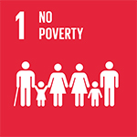
SDG1 End poverty in all its forms everywhere

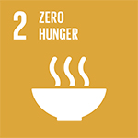
SDG2 End hunger, achieve food security and improved nutrition and promote sustainable agriculture

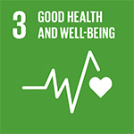
SDG3 Ensure healthy lives and promote well-being for all at all ages

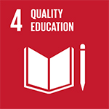
SDG4 Ensure inclusive and equitable quality education and promote lifelong learning opportunities for all

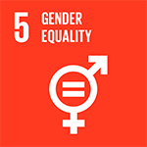
SDG5 Achieve gender equality and empower all women and girls

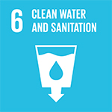
SDG6 Ensure availability and sustainable management of water and sanitation for all

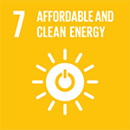
SDG7 Ensure access to affordable, reliable, sustainable and modern energy for all

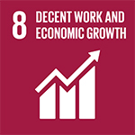
SDG8 Promote sustained, inclusive and sustainable economic growth, full and productive employment and decent work for all.

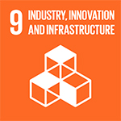
SDG9 Build resilient infrastructure, promote inclusive and sustainable industrialization and foster innovation.

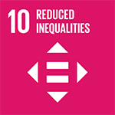
SDG10 Reduce inequality within and among countries

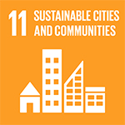
SDG11 Make cities and human settlements inclusive, safe, resilient and sustainable

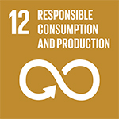
SDG12 Ensure sustainable consumption and production patterns

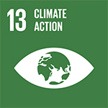

SDG13 Take urgent action to combat climate change and its impacts

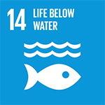
SDG14 Conserve and sustainably use the oceans, seas and marine resources for sustainable development

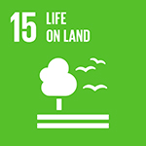
SDG15 Protect, restore and promote sustainable use of terrestrial ecosystems, sustainably manage forests, combat desertification, and halt and reverse land degradation and halt biodiversity loss

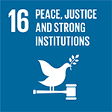
SDG16
Promote peaceful and inclusive societies for sustainable development provide access to justice for all and build effective, accountable and inclusive institutions at all levels

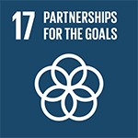
SDG17
Strengthen the means of implementation and revitalize the global partnership for sustainable development

BECOME A PARTICIPANT!
BECOME A PARTNER!
BECOME A MEMBER OF THE JURY!

CONTACT US:
The UK: +44-131-217-80-28
Official Website: www.startupworldcup.biz

General Educational Partners
MINIBOSS BUSINESS SCHOOL: www.miniboss-school.com
BIGBOSS BUSINESS SCHOOL: www.bigboss-school.com

