STARTUP WORLD CUP CHAMPIONSHIP
FOR KIDS AND TEENS
COUNTRY DAY

Country Day is a solemn global event, which marks the friendship of countries and international cooperation, and anticipates the Startup World Championship.
The day of the country is held on the 2nd day of the World Championship for global familiarization with the participants of the championship, their countries and culture.
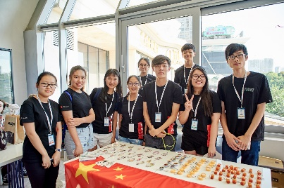
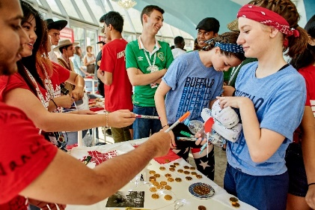
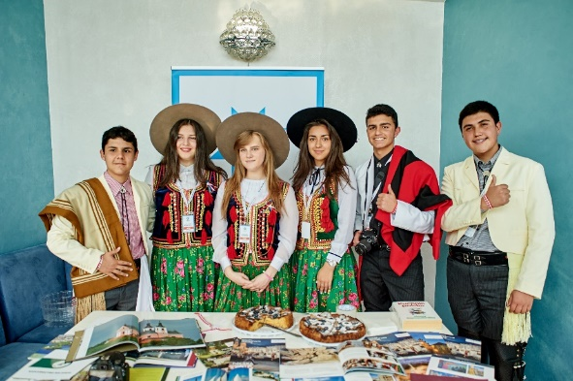
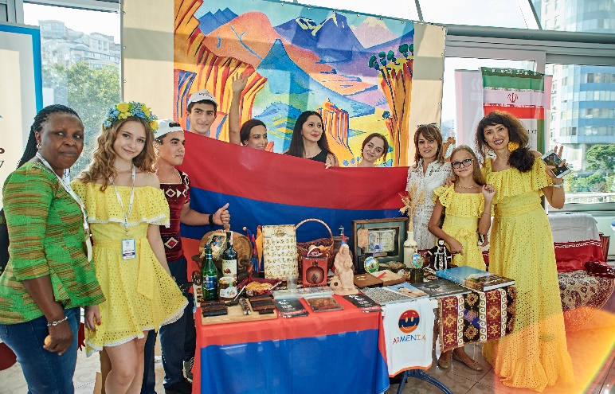

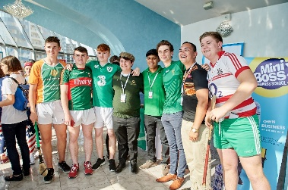

Country Day is held in a large room and consists of the following elements:
• COUNTRY EXPO-STAND (each country is provided with one table), at which everything that reveals the coloring of the country is presented (flag, printing, postcards, national souvenirs and food, the other is at your discretion). All participants exchange souvenirs and sell their projects’ goods made for the Championship. Recommendation: take at least 100 pcs of souvenirs to the booth;

• NATIONAL COSTUMES (all members of delegations come to this event in national costumes, demonstrating the culture and customs of their country);

• CULTURAL SHOW (short story about the country / presentation up to 1 minute, slides, national songs, dances, etc). All performances from the country are prepared by the children themselves under the guidance of teachers and last up to 15 minutes for 1 country;

• COUNTRY PARADE - at the end, all countries go on the stage with flags on the Parade.

Parents of members of national delegations form an additional budget for the purchase of all necessary additional materials to adequately ensure that the children present their country at the World Championships.

Participation in the Country Day helps to form among students:
- a sense of belonging and pride for their country, patriotism,
- a sense of globalism and responsibility for our Planet,
- a sense of unity and global communication,
- the desire to better learn the culture of their country,
- the desire to learn the cultures of other countries,
- the desire to cooperate in the business and cultural sphere.
