STARTUP WORLD CUP
CHAMPIONSHIP
JUDGEMENT
STARTUP WORLD CUP CHAMPIONSHIP is the main world’s annual event for young entrepreneurs.
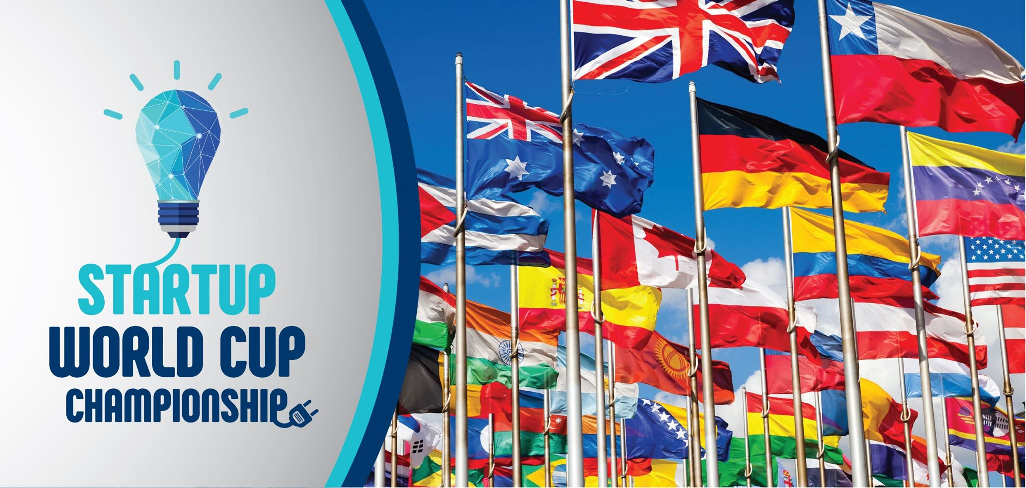
JUDGE REGISTRATION
1. An entrepreneur, a top manager of a company, a representative of a sponsor company, a representative of local municipal authorities or state government may become a member of STARTUP WORLD CUP CHAMPIONSHIP jury;
2. Each national delegation may submit to the jury not less than 1 and not more than 10 entrepreneurs;
3. Registration fee (200 €) for participation in the official Judge panel of STARTUP WORLD CUP CHAMPIONSHIP is mandatory for each jury member. All fees go to the PRIZE MONETARY FUND and distributed to the winning teams in the proportion according to the winning places;
4. Each member of the jury may express his social responsibility and allocate more than 200 € to the prize monetary fund to support a new generation of entrepreneurs;
5. PRIZE MONETARY FUND of the World Championship is open - all names and sums entered by the jury members will be published (if the jury member does not object to the announcement of this information) on the main website of Championship (www.StartupWordCup.biz), as well as on the websites of the general educational partners - International Educational Network MINIBOSS BUSINESS SCHOOL and International Educational Network BIGBOSS BUSINESS SCHOOL;
6. Before judging all members of the jury will be briefed on clarifying the evaluation criteria for each nomination;
7. Each member of the jury signs an oath on the objectivity of international refereeing;
8. Each jury member receives a diploma.

JUDGEMENT: RULES OF COMPETITION
- STARTUP WORLD CUP CHAMPIONSHIP language is English;
- Each team prepare and submit a 3-minute presentation of the startup to the jury members;
- The jury members evaluate the performances of the teams for compliance with the evaluation criteria by the following levels:
- written Annual report,
- oral presentation,
- answers on questions.
- Each team is required to create a written (typed) annual report of its educational outreach projects. Annual report is limited to four single sheets of A4 print only one side of the sheet. If a team uses a cover or back page, it will count as one of those 4 pages.
- Annual reports are distributed to the judges during the set-up period as outlined below. Teams are required to bring 30 copies of Annual Report to the competition.
- Each team will have a 10 minutes time block for its verbal/audio/visual presentation. The league coordinator will keep the official time. After the league coordinator formally introduced the team, the time be precisely divided as follows:
- Equipment set-up and annual report distribution – 2 minutes,
- Live audiovisual presentation – 3 minutes,
- Q & A period – 2 minutes (If teams require a translator will be given an additional 3 minutes for Q & A,
- Tear down equipment and exit room – 1 minute.
- Teams must present at World Championship evidence of a successful project:
- goods in realia,
- description of the implemented startup in the form of Annual Report (no more than 4 pages of printed version, A4 format),
- description of the implemented startup in the form of oral presentation,
- links to websites and social media, any other evidence.
- Each nomination has its own criteria for evaluation;
- After all the teams in your league have concluded their presentations, the judging process will occur as follows:
- Take a few minutes to review and make any additional comments on the evaluation sheets. The SWCC staff plays no role in the judging process. Please do your best to complete these evaluations thoroughly and try to offer feedback that is positive in nature, but also provides suggestions how the team can improve.
- Use the cumulative score to rank each team in order, giving a number one ranking to the team you think did the best overall job of fulfilling all judging criteria, a two to the second, and so on. A tie between two or more teams is not permitted – please rank each team from first to last, assigning no two teams the same rank.
- Turn your evaluation sheets into the league coordinator.
- The results will be announced at an awards ceremony, which you are invited to attend.

LEAGUES
AT STARTUP WORLD CUP CHAMPIONSHIP, students present their startups in TWO AGE LEAGUES:
- MINIBOSS Junior League (children and teenagers 6-14),
- BIGBOSS Senior league (youth 15+).

CATEGORIES/ NOMINATIONS
The jury members evaluate startups in two categories:
- INNOVATIVE ENTREPRENEURSHIP
(SIFE - Startups in innovative free entrepreneurship)
These entrepreneurs start a company knowing from day one that their vision could change the world. Innovators are the types of entrepreneurs who come up with completely new ideas and turn them into viable businesses.
In most cases, these entrepreneurs change the way people think about and do things. Innovative startups are always commercial (for-profit).

- SOCIAL ENTREPRENEURSHIP
(SAGE - Startups for the advancement of a global environment).
Social entrepreneurs are innovators who focus on creating products and services that solve social needs and problems. However, unlike scalable startups their goal is to make the world a better place, not to take market share or to create to wealth for the founders. They may be nonprofit, for-profit, or hybrid.
Social startups can be non-profit, commercial (for-profit) or hybrid.

JUDGING CRITERIA: SIFE category

 | Judging Criteria for SIFE | Maximum Point Value
1. | INNOVATION (NOVELTY)  How effective was the team in generating a fundamentally new idea? Does this idea have competitors? What did the team invent new? How does this affect the life of the target audience?  POOR GOOD EXCELLENT | 30
2. | PROFITABILITY  How effective was the team in spending resources and earning revenue? Is this% of profitability higher than the average interest rate on deposits in the country? What did the high profitability mean? How correctly did the team calculate profitability?  POOR GOOD EXCELLENT | 30
3. | SCALING  How widespread is the project? How big is the production? How many sales points does the project have?  POOR GOOD EXCELLENT | 20
4. | MEDIA COVERAGE  How widely did you use media to popularize the project? How many media sources? How many exits? What is the general media coverage of the audience?  POOR GOOD EXCELLENT | 10
5. | QUALITY Q & A PERIOD  How convincing were the answers? How much did the teamwork feel when answering questions?  POOR GOOD EXCELLENT | 10
 | Total | 100 points

JUDGING CRITERIA: SAGE category

 | Judging Criteria for SAGE | Maximum Point Value
1. | SOCIAL UTILITY (RELEVANCE)  What is the social benefit of the idea? What problem does the team solve in society? What will society get as a result of solving this problem through a team project?  POOR GOOD EXCELLENT | 30
2. | SOCIAL RESOURCES (STAKEHOLDERS)  What social resources are involved (public organizations, volunteers, international, government organizations, etc.)?  POOR GOOD EXCELLENT | 30
3. | SOCIAL IMPACT (SCALING)  How widespread is the project? How big is the production? How many sales points does the project have?  POOR GOOD EXCELLENT | 20
4. | MEDIA COVERAGE  How widely did you use media to popularize the project? How many media sources? How many exits? What is the general media coverage of the audience?  POOR GOOD EXCELLENT | 10
5. | QUALITY Q & A PERIOD  How convincing were the answers? How much did the teamwork feel when answering questions?  POOR GOOD EXCELLENT | 10
 | Total | 100 points

STARTUP WORLD CUP
CHAMPIONSHIP
JUDGE’S OATH

On my Honor, I agree to serve today
as an official judge of SWCC competition
in a completely fair and impartial manner.

I personally commit to this responsibility
with no previous conflicts of interest
or pre-determined expectations
for the outcome of the competition.

I will make my evaluations based entirely
on the teams’ presentations and written Annual Reports
using only the judging criteria provided to me.

I will make my judging decisions with integrity
and without regard as to the schools, universities
or country represented by the teams.

I promise to provide fair judgment
and show a worthy example of honesty
to the new generation of entrepreneurs!

