September 10, 2019 Representatives of business communities

DEAR AMBASSADORS AND CONSULES,
DEAR ENTREPRENEURS!

On behalf of International Business Academy and European Association for Business Development, we invite you to 2020 GLOBAL BUSINESS FORUM & EXPO, which will be held on July 5, 2020 in London (UK) from 10 am to 3 pm as part of STARTUP WORLD CUP CHAMPIONSHIP!

BIGBOSS GLOBAL BUSINESS FORUM & EXPO 2020 is an important event in the world of innovative entrepreneurship. Business representatives from around the world will arrive in the UK to participate in the Global Business Forum and the World Championship 2020. BIGBOSS GLOBAL BUSINESS FORUM & EXPO 2020 is designed to introduce and unite the world's business people to promote the development of innovation and entrepreneurship.

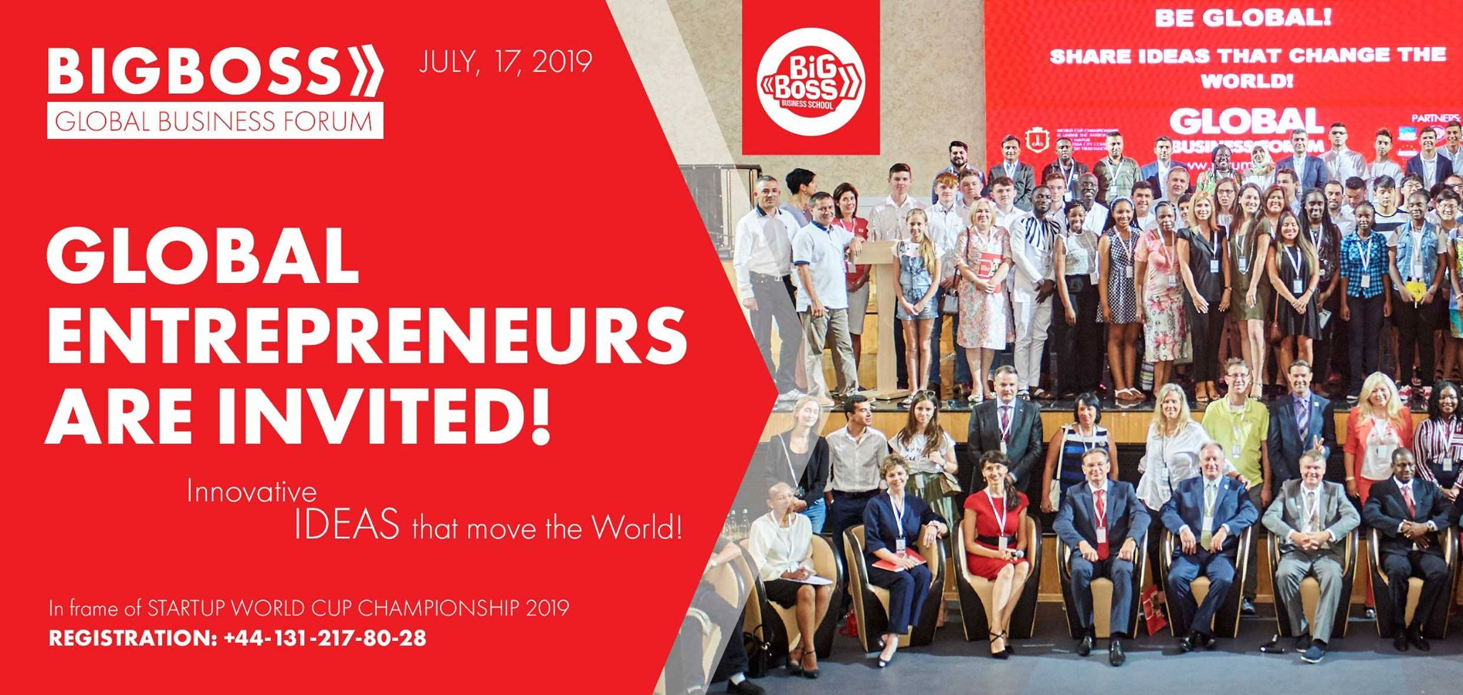

BIGBOSS GLOBAL BUSINESS FORUM & EXPO 2020 is a global platform for business networking, useful business acquaintances, finding partners or representing your company for clients in the global international market!

If you have an outstanding innovative business, you can become a SPEAKER of the Forum. Detailed information by phone: + 44-131-618-91-02.
MANDATORY ONLINE REGISTRATION: bigbossglobal100@gmail.com

DEVELOP BUSINESS OPPORTUNITIES OF YOUR COUNTRY!
BECOME A PART OF THE GLOBAL BUSINESS WORLD!

Respectfully,
Head of the Organizing Committee Andrei Azarov

PROGRAM

9.00-10.00 - Registration for the Forum;
9.30-10.00 - PRESS CONFERENCE;
9.00-10.00 - Inspection BUSINESS FAIR, negotiations B2B;
10.00-10.45 - GRAND OPENING OF BIGBOSS GLOBAL BUSINESS FORUM & EXPO 2020. Speech by officials;
10.15-13.00 - SPEECHES OF ENTREPRENEURS;
13.00-14.00 - BUSINESS LUNCH (only for Forum speakers);
13.00-16.00 - continuation of B2B meetings at BUSINESS FAIR locations;
16.00-19.00 - the announcement of the finalists of the Startup World Cup 2020, the draw, the performance of the finalists.
19.00-21.00 - COUNTRY PARADE (flag parade, global cultural networking).

BECOME A PART OF THE GLOBAL BUSINESS WORLD!

