OFFICIAL INVITATION
TO STARTUP WORLD CUP CHAMPIONSHIP 2019 MINIBOSS & BIGBOSS
Bulgaria, Kamchia

Organizer: International Education Network MINIBOSS & BIGBOSS BUSINESS SCHOOLS.
General Partner: Municipality of Burgas, Bulgaria.
Call: +44-131-618-91-02 (in English)
Call: +38-093-313-2222 (in Bulgarian/Ukrainian/Russian)
Head of organizing committee: Olga Azarova (+44-131-217-80-28; +38-093-305-38-88)
Local Curator: Helena Khodakovskaya (+359-899-319-534).
OFFICIAL WEBSITE: www.startupworldcup.biz

27 May 2019 № 1/0001 For those who may concern

DEAR OFFICIAL DELEGATION!

This is a special invitation to OFFICIAL DELEGATION in your country to participate in the annual STARTUP WORLD CUP CHAMPIONSHIP 2019, which will take place 11-21 July, 2019 in Kamchia, Bulgaria.

As the MINIBOSS BUSINESS SCHOOL Official Franchisee, you are invited to lead a delegation of kids and youth (and their adult allies) to represent your country at this educational global event. Please use this letter for visa purposes.

MINIBOSS BUSINESS SCHOOL mission is to help create the next generation of entrepreneurial leaders whose innovations and social enterprises address our world’s major unmet needs. MINIBOSS BUSINESS SCHOOL has developed an innovative educational system for the training of innovative entrepreneurs around who are capable of serious transformations in society in order to solve social problems and improve the standard of living of society.

MINIBOSS BUSINESS SCHOOL has been organizing championships since 2000.

At the end of the academic year, the teams travel to a tournament to present the results of their innovations to a panel of jurists recruited from the business and civic community, to demonstrate innovative startups as an intellectual potential of the country. Championships evaluate two types of projects: innovative and social.

From 11-21 July, MINIBOSS BUSINESS SCHOOL teams from 12 countries will be vying to be this year’s World Cup Champion. This is the 19th year that the World Cup will take place.

As each country makes its plans to participate, please bear in mind that:
- The official member of the delegation for the World Cup can be:
- MiniBoss or BigBoss Business School student,
- his parents / relatives,
- other observers of the championship,
- entrepreneurs as jury members from the country,
- official representatives of the authorities and the municipality as guests of honor;
- Each National delegations pay their own expenses (lodging, meals, ground transportation to and from the airport) by purchasing vouchers.

Also, please understand that you and your traveling delegation are responsible for making your own travel and transportation arrangements to Kamchia. The information required for your visa is attached.

If you have any questions, please don’t hesitate to contact me.

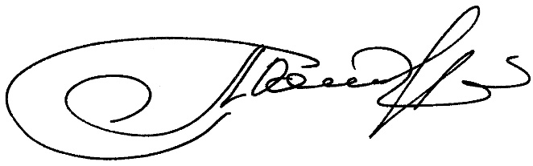

Sincerely,

Olga AZAROVA
STARTUP WORLD CUP CHAMPIONSHIP 2019 Head of organizing committee,
MINIBOSS BUSINESS SCHOOL Founder & CEO
+44-131-217-80-28;
+38-093-305-38-88
E-mail: olgaazarova100@gmail.com

