WOMEN BUSINESS ACADEMY
presents

Parent Coaching Program
"FAMILY DNA"
in honour of the 20th anniversary of
MINIBOSS & BIGBOSS BUSINESS SCHOOLS International Education Network

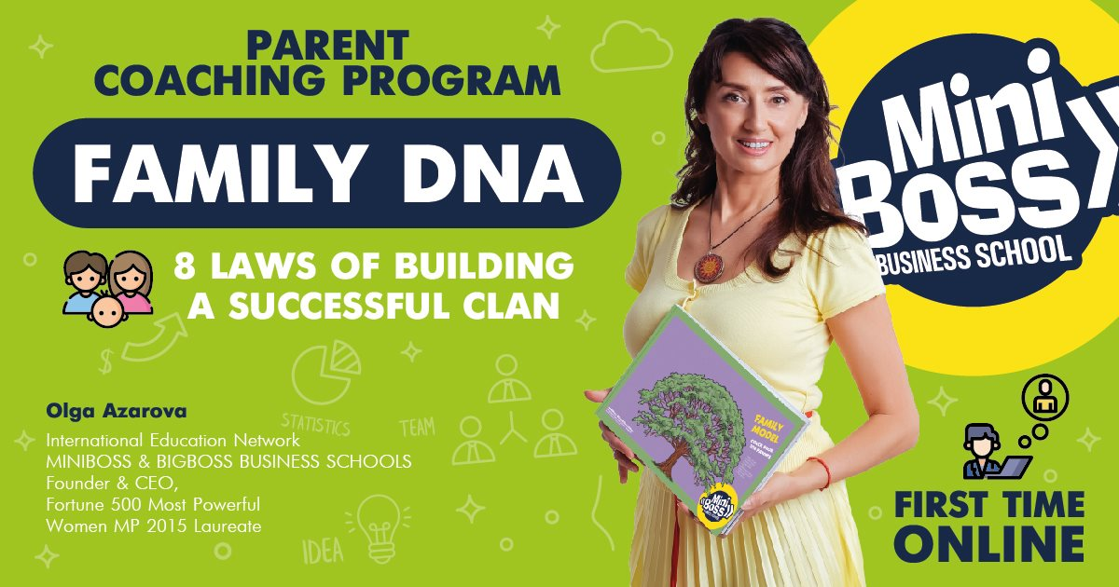

PROGRAM

WORKSHOP # 1
1st module
1. INTRODUCTION TO FAMILY COACHING. GOALS AND OBJECTIVES OF THE COURSE
2. NEUROBIOLOGY AND MY FAMILY: how it works

2nd module
3. LIFE AS A SYSTEM. MY GOALS AND ME
4. “WANT-DO” SYSTEM ANALYSIS

WORKSHOP # 2
3rd module
5. FAMILY AS A SYSTEM. TYPES OF FAMILY RELATIONS

4th module
6. LAWS OF BUILDING A SUCCESSFUL FAMILY CLAN (# 1 and # 2)

5th module
7. FAMILY GENOGRAM
WORKSHOP # 3
6th module
8. NEUROBIOLOGY: HOW WE SEE THE WORLD.
9. THEORY OF THE TRIUNE BRAIN. THE CONCEPT OF "INTELLIGENCE"
10. LAWS OF BUILDING A SUCCESSFUL FAMILY CLAN (# 3 and # 4)

7th module
11. CORE OF HAPPINESS. EMOTIONAL INTELLIGENCE OF THE FAMILY
12. IDENTIFICATION OF ITS CHRONIC TONE

8th module
13. EMOTION MANAGEMENT: DETOX and ANTISTRESS
14. CREATING A HEALTHY EMOTIONAL ENVIRONMENT

WORKSHOP # 4
9th module
15. CORE OF WEALTH. BEHAVIORAL STRATEGIES.
16. LAWS OF BUILDING A SUCCESSFUL FAMILY CLAN (# 5 and 6)
17. RESEARCH: FIND OUT THE CORE
18. BUILDING A “FAMILY MODEL”
- family values
- Family code
- family heraldry
WORKSHOP # 5
10th module
19. LIST OF PERFECT QUALITIES OF THE FAMILY. LAWS OF BUILDING A SUCCESSFUL FAMILY CLAN (# 7 and 8)
20. FAMILY STORYTELLING AS A LEGACY
21. Feedback from participants
22. Certification.

Volume: 900 minutes of family succession plan - 10 academic hours of theory and 10 academic hours of practice.

Price: One ZOOM Workshop (2 educational modules) - 200 euro / person.

Full course: five Workshops (10 modules) - 1000 euro / 1 person.
+ FREE participation of WORLD WOMAN CLUB members on the 1st workshop!
+ FREE participation of the spouse in a coach program!
+ COACH-BOOK as a gift!

Dates: April 20, 23, 27, 30, May 4, 2020.

Time: from 6.00 to 7.30 pm (2 modules per day for 45 minutes each) by Moscow/ Kiev/ Sofia / Vilnius time.

Connection technology:
• Your Facebook account will be added to the Coach program chat,
• The chat link to the Zoom conference will be reset to the chat 1 day before the start,
• The working materials of the coach program for the practical work of each participant (coach book for each module) will be posted in the chat,
• The announcements of the following modules can be monitored on the website: https://iba-consortium.com/FAMILYDNA

SEE YOU SOON!

