Dear (first name)

Greetings from the WORLD’S # 1 BUSINESS SCHOOL!

[either refer to the phone conversation, or leave the below paragraph]

You sent us a request for more information to enrol your child in our school.
We are happy to assist you in joining your child to the most advanced innovative education programs.

MINIBOSS BUSINESS SCHOOL is world’s brand # 1 in business education for kids and teens, global education network for future leaders of the world!

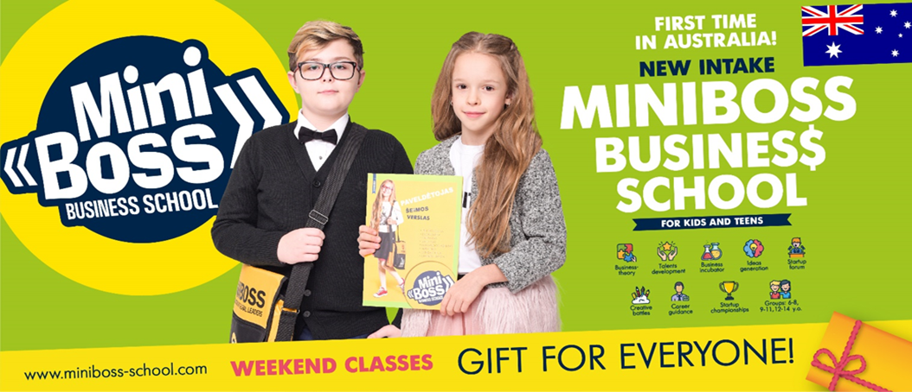

To become an entrepreneur and be able to create unique business ideas and bring them to life, you need to be able to do a lot: know a lot of theory, find and develop all your talents and most importantly, you need to develop your ability to turn theory into successful projects. That is why the MINIBOSS BUSINESS SCHOOL academic program consist of 8 courses of theory and 12 types of practice annually, including the world's only Children's Business Incubator, Master classes with top executives of businesses, Startup Forums, Business festivals, Business tours, Family Business Camps and Startup World Cup Championships!

MINIBOSS course for kids aged between 6 and 14.

The lessons in MINIBOSS are interesting and very useful, they are held according to the author's game methodology. Young entrepreneurs of the world, as well as child leaders in Australia, study in various branches in different countries: they study business theory, personality development psychology, generate ideas, create their own teams, create their own startups, receive first capital and present projects at the Startup World Cup Championship.

Upon completion of the program, the student obtain the main thing - unleashing his potential by 100%, developing 8 super-personality intellects, self-confidence proved by his own startups, and the International Diploma (UK), confirming that the student has already become successful!

GIVE YOUR CHILD SUCCESSFUL FUTURE! JOIN US!

Please find attached:
- MINIBOSS Academic Program and Tuition,
- MINIBOSS + LEO Special Offer Options
- Application form.

Feel free, please, to familiarise yourself with our standard Service Agreement and a Privacy Policy.

More info about us:
The MINIBOSS BUSINESS SCHOOL International Education Network was founded in 2000. MINIBOSS operates 56 business schools in various countries of the world.
Since 2000, MINIBOSS has graduated over 5,000 graduates, and we're proud that most of them keep running some of the businesses they started during our courses. Most of them are successful individuals - innovative and social entrepreneurs, who invent new goods and services, create new enterprises and jobs, pay taxes on the entire state budget sphere. They change the world for the better every day.

For 20 years, MINIBOSS has repeatedly proved its effectiveness in training leaders of the 21st century who are capable of realizing their dreams and of significantly transforming the economy and people's living standards.

These are a few videos about activities we offer:
- MINIBOSS LESSONS OVERVIEW
- STARTUP WORLD CUP
- STUDENTS STARTUP PROJECTS
- MASTER CLASSES
- FAMILY BUSINESS CAMPS

If you have any further questions, please call on 0450 901 660.

WELCOME TO MINIBOSS WORLD!

Kind regards,
Elena Chirich
Director
MINIBOSS BUSINESS SCHOOL (Brisbane)
0450 901 660

