DESCRIPTION of the
MINIBOSS MASTER CLASSES

Master Classes MINIBOSS BUSINESS SCHOOL is a form of studying the theoretical and practical foundations of business from top officials of the companies (founder, director) specifically for young entrepreneurs - students of the International Education Network MINIBOSS BUSINESS SCHOOL.

SPEAKERS for MASTER CLASS: there are well-known entrepreneurs in your country / city who have created well-known brands and have significant business experience.

TOPICS OF MASTER CLASS: at the discretion of the speaker.

TIME: 60-90 minutes.

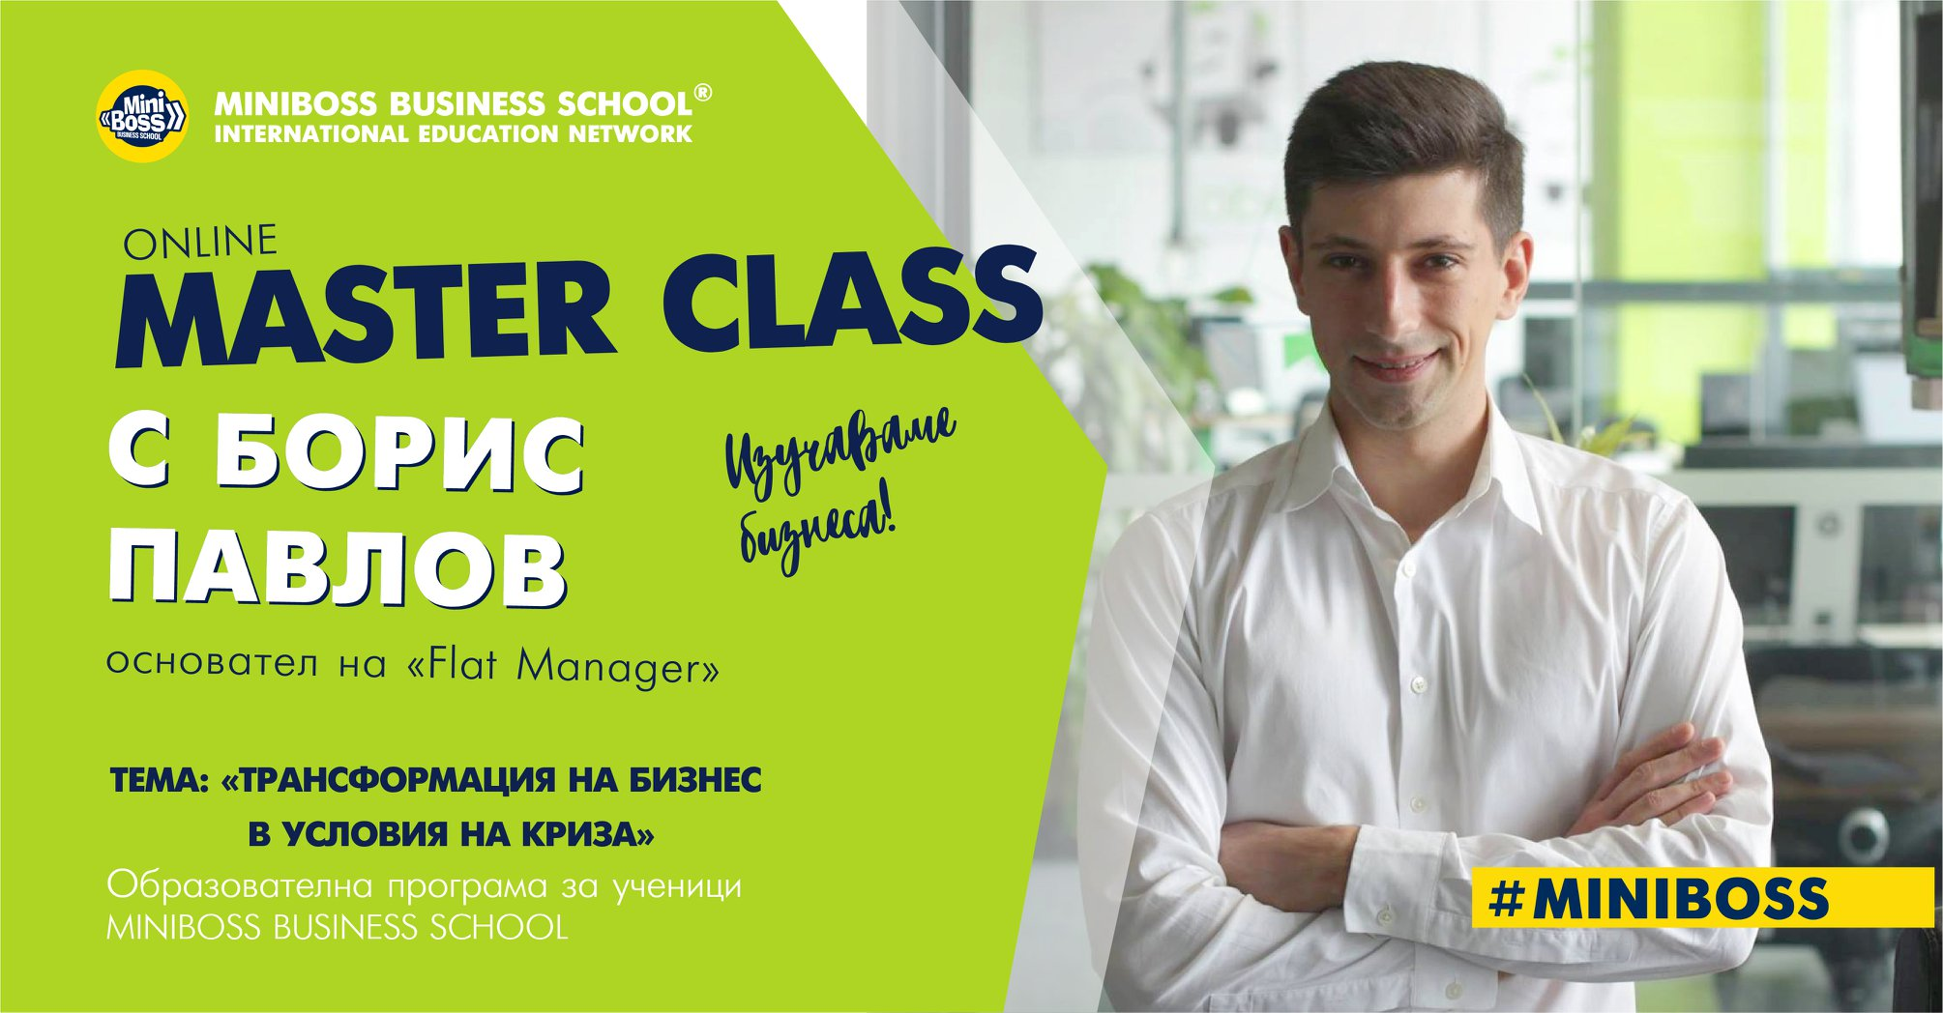

FORMAT OF MASTER CLASS:
1. Introducing yourself
2. Excursion of the company (if possible)
3. Introduction and presentation of the theme of the Master Class
4. Questions and answers of MINIBOSS students
5. Gifts and advertisement materials for MINIBOSS students (optional).

Master classes are held in the 2nd semester of each year.
Students make notes about the Master Class in their workbooks (at the end).

MEDIA SUPPORT: The information partners of your local MINIBOSS BUSINESS SCHOOL, in consultation with the speaker, can film this event.

MEDIA SHARING: Information about the Master Class (PR about the person and his company) is shared in social media, in partner media and at the global and local resources of the International Education Network MINIBOSS BUSINESS SCHOOL (at least 10 posts on pages and in groups for Facebook, Instagram, Twitter, LinkedIn), and also on the site www.miniboss-school.com.

