Dear Franchisee!
Dear Clients, Dear partners,

International Education Network MINIBOSS BUSINESS SCHOOL is carefully following the decisions of the World Health Organization (WHO) concerning the «Coronavirus» situation. MINIBOSS BUSINESS SCHOOL pays extremely attention to the health and well being of all our employees, students and partners.

Taking into account the expert assessments of scientists about the supposedly long period of the pandemic, and also taking into account our values ​​about the high quality and timeliness of education, as well as the safety of our students and staff, we decided to provide learning for our students around the world online (during the pandemic).

Thanks to our solid infrastructure and experienced IT team, we were able to setup a new way and platform within the International Education Network in order to ensure the total continuity of our services.

From the first day of the pandemic, March 12, we switched to online training. We completely adapted all our lessons to the format of online teaching and preserving the game form and tools for the deep assimilation of information. This year, during the pandemic, we will also host the Startup Forums, National Championships and the World Startup Championships online. All modules will be conducted according to the current schedule (no changes) with the same teachers and, as always, at a high professional level.
All our classes will be held continuously online for the duration of the epidemic.
The online format provides more opportunities for both new and current students. Children aged 6-14 easily communicate with each other through a gadget (much better than adults), know modern applications and programs and easily adapt to the innovations of the digital age. Therefore, I will accurately predict that this change will positively affect the work of all branches, as it will add skill to children in monetizing their projects through Internet services and to teachers and franchisees in the development of new digital technologies.
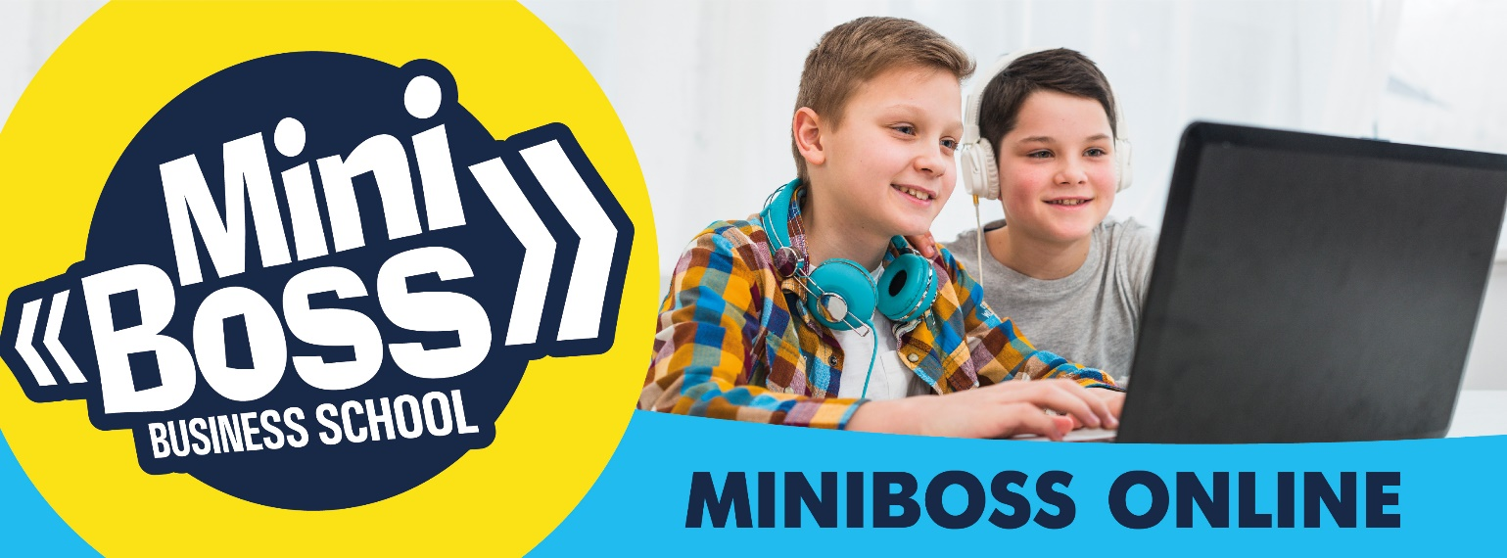

Parents are required to help their children connect to the services offered by the official branches of MINIBOSS BUSINESS SCHOOL in your region and to establish their access to the first lessons. Then the communication will be automatic.

We wish you success in the rapid and effective development of digital technologies for global business education!
All changes for the better!

Stay healthy and happy!
Take care of yourself, your parents and children!

Respectfully,
Olga AZAROVA
MINIBOSS BUSINESS SCHOOL
Founder and CEO

