Dear Franchisee!
The main office of MINIBOSS BUSINESS SCHOOL International Educational Network, taking into account the protracted nature of this crisis caused by the coronavirus pandemic, strongly recommends not stopping (and not postponing) children’s education, and simultaneously transfer all classes online, no later than March 21-22, 2020.

For advertising and PR online directions we offer:

- use the following facebook headers (replace the headers on your personal profiles in fb),
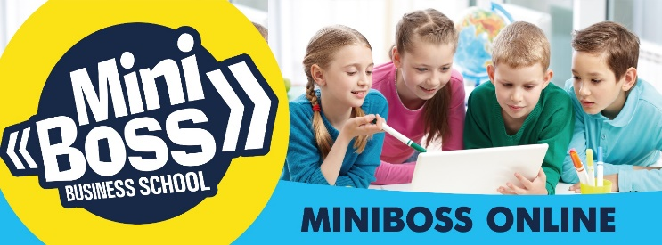

- use the following facebook headers (replace the headers on the page in fb),

- add a corporate frame for your personal photo on fb, emphasizing the importance of the new direction online.

You can find links to mockups in your dashboard, Design Cloud or at this link: https://fex.net/ru/s/p6tvpxk

Sincerely,
Design Department

