ACADEMIC PROGRAMME & TUITION FEES

MINIBOSS BUSINESS SCHOOL
NEW INTAKE 2023

GLOBAL BUSINESS EDUCATION
FOR KIDS & TEENS

Age Groups: 6-8, 9-11, 12-14, 14-17

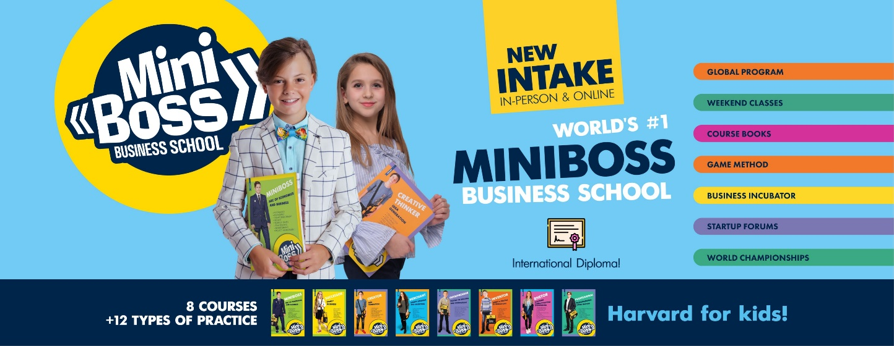
In-Person & Online
The purpose of education
Before 18th century, children did not go to schools at all. The first mass public schools were invented 150-170 years ago only with purpose to train future workers for factories and plants.
In the 20th century, children went to school for the sake of a certificate, which gave them a right to work and a right apply to university.
In the 21st century, children and parents want the main thing from schools to unleash the personal full potential of each child and develop their abilities to achieve dreams.
However, any private or public regular schools in the world do not care about real life skills. Regular School purpose is to provide a teaching of theory of subjects. Therefore, we filled in the missing part in modern education – MiniBoss World-Class Business Education as additional weekend classes for young leaders of the Globe.
MINIBOSS BUSINESS SCHOOL focuses on the unleashing students’ FULL POTENTIAL and skills how to MONETIZE the knowledge gained, taking into account the talents of everyone.
MINIBOSS BUSINESS SCHOOL is the world’s one & only education network for entrepreneurial education for kids and teens with unique Programmes and 12 types of practice!
6-17 is a key age for MINIBOSS
It has been scientifically proven that at an early age from 6 to 17 years old people have the highest neuroplasticity - our brain is able to absorb EVERYTHING (both good and bad patterns of behaviour), forming a strong or weak character. Therefore, it is important what we learn in childhood.
Starting to form character from 6, 9, and 12 years old, we still have time to influence the formation of personality!
It is too late to start developing your skills at the university age.
Why is not enough to be just SMART?
Having the best grades in school does not guarantee that you will be successful in life.
Just the opposite, we often see inversely proportional statistics between grades and success in life. Why? No matter how much knowledge you have, what matters is your ability to turn any knowledge into practice (into a successful project!). This is the most important KPI of modern education!
These are completely different competencies: just memorizing knowledge or applying them, being a lone know-it-all or being a team leader who takes responsibility!
Therefore, in the 21st century it is extremely important to be not just smart, but also SUCCESSFUL who have proven the value of their mind in practice. Moreover, this means being able to survive in different situations, to take care of a family, to be not just a professional, but earn a lot, take risks consciously and not be afraid to invent and implement new ideas into real life, negotiate and sell....
All of this requires eight basic intelligences (MINIBOSS 8Qs Innovative Method)! We develop not just IQ only like in public schools, we develop strong and creative personality for a successful future - 7 more Qs. Do you want to know about it?

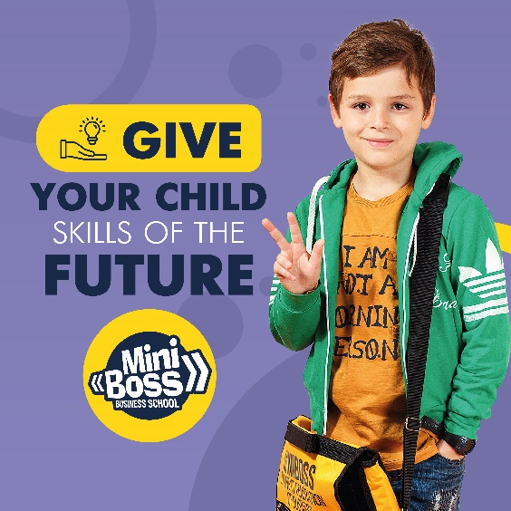

What and how do children study at MINIBOSS?
In MINIBOSS, children study eight courses gradually developing their eight basic intelligences through the unique 8Qs Method.
Students study 18 subjects (from psychology to talent management studies, from rhetoric to marketing, from invention to entrepreneurship) CONSCIOUSLY shaping their character, skills and future.
What will students learn in MINIBOSS?
From an early age, a MINIBOSS student will learn eight essential things:
- PRACTICE - how to turn any knowledge into a real project!
- PROBLEM SOLVING - the main skill that distinguishes successful from unsuccessful,
- MOTIVATION - the ability to turn your laziness into a desire to achieve your DREAMS!
- INVENTION - the development of creative qualities for the creation of NEW IDEAS!
- HEALTHY ENVIRONMENT – the ability to find friends with motivation and family values,
- TEAM WORK - the ability to negotiate and build a mechanism that achieves goals!
- LEADERSHIP - the ability to lead and be a role model!
- GLOBAL - the ability to present results of academic year on the global stage as a participation in STARTUP WORLD CUP CHAMPIONSHIPS, turning your fears into a skill to win! Develop contacts with world leaders!
MINIBOSS Scientific Integrity
Yes, even the first course will give to a child significant benefits and visible changes! At the same time, it is important to complete the full programmes (8 courses and 12 types of practice). Every year a certain type of intelligence develops according to the 8Qs Method - therefore only a holistic approach gives full unleashing of potential and guarantees of 100% success of training. The skills developed in MINIBOSS bring HAPPINESS AND SUCCESS to children in life!
Proven by the experience of more than 9,000 of our graduates!
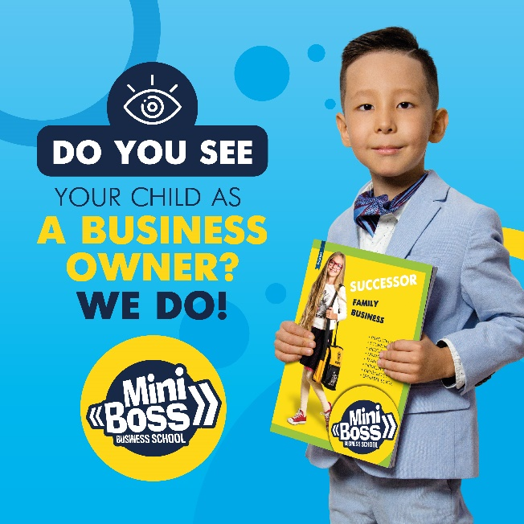
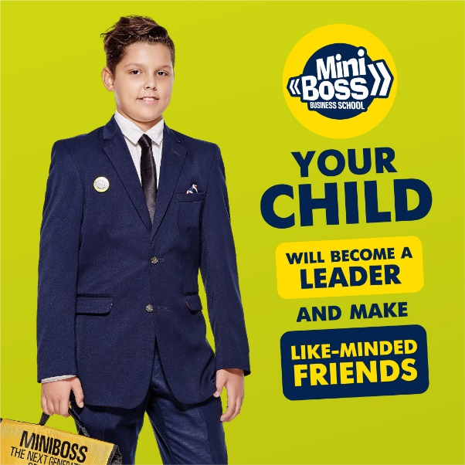
Upon completion of the full programme, students receive a MBBS/ UK INTERNATIONAL DIPLOMA!
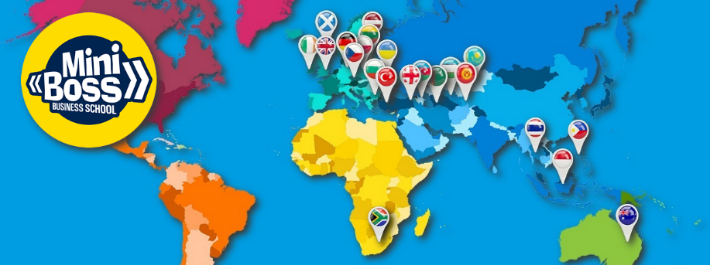
ACADEMIC PROGRAMME & TUITION FEES

Name of Educational Packages: | PACKAGE # 1.  SHORT COURSE  FOR BEGINNERS | PACKAGE # 2.  FULL COURSE  WORLD CERTIFICATION
OPTIONS | - BUSINESS THEORY  - TALENTS DEVELOPMENT  INTERNATIONAL  MINI-CERTIFICATE | - BUSINESS THEORY  - TALENT DISCOVERY  - 12 TYPES of PRACTICE  - CHAMPIONSHIPS  - DEEP CAREER GUIDANCE  INTERNATIONAL  CERTIFICATES & DIPLOMA
Tuition fee per Course: | 3,500 €/course | 4,500 €/course
Cost of 1 academically hour: | 33 €/hour | 19 €/hour
Academics  (academic hours in the course): | 90  (9 months  or 6/ 3 - intensive) | 204  (10 months  or 6/3 intensive)
For Whom? | For those who are not confident yet in their abilities and want to “try” with a focus on business theory only: game methods and unleashing their talents, but without startup practice.  This package will provide the minimum required knowledge without practice (mini-certificate), which is not enough to issue an International Certificate and Diploma. | For those who need an International Diploma (after completing 8 courses) and a full-fledged potential by completing a full programme of theory and practice for business skills.  This package includes all obligatory elements of the Academic Programme that guarantee the International Certificate & Diploma of MINIBOSS BUSINESS SCHOOL (UK) awarding.
Name of Educational Packages: | PACKAGE # 1.  SHORT COURSE  FOR BEGINNERS | PACKAGE # 2.  FULL COURSE  WORLD CERTIFICATION
THE PACKAGE INCLUDES PARTS
OF THE ACADEMIC PROGRAMME:
- Career Guidance 1st Lesson  (personal interview)  - up to 1 acad. hour per a course. | YES | YES
- Business Theory  with Unique Personal Study Books  Online or In-Person  (in cities with licensed branches)  - 76 acad. hours per a course.  Every year a new course.  Full programme consist of 8 Courses:  Course No.1  MINIBOSS  (the basics of self-awareness, economics and business)  Course No.2  SUCCESSOR  (the basics of a family business system)  Course No.3  CREATIVEMAN  (the basics of creativity and divergent thinking in business)  Course No.4  MERCHANT  (R&D, marketing and creation of "blue oceans")  Course No.5  ENTREPRENEUR  (startup history and evolution)  Course No.6  INVENTOR  (TIPS and the theory of invention basics)  Course No.7  RHETOR  (human capital and building networking)  Course No.1  PROFI  (deep career guidance - find your calling) | YES | YES
3. Masterclasses - studying businesses in reality.  - up to 10 acad. hours (5 classes). | YES | YES
4. Teambuilding  - 2 acad. hours. | − | YES
5. Business Incubator (Practice) - 42 acad. hours including:  - Project management from A to Z ,  - Personal and team mentoring,  - Professional consulting - legal, financial, etc. | − | YES
6. Startup Forum  - 8 acad. hours per a course. | − | YES
7. Startup National Cup Championship (SNCC), including registration fee of  £50 per person.  - 8 acad. hours per a course. | − | YES
8. Startup World Cup Championship (SWCC), including the registration fee of  £100 per person.  - 32 acad. hours per a course. | − | YES
9. Online or In-Person Team Mentoring  - at least 20 acad. hours per a course. | − | YES
10. MINIBOSS City Startup Camp - an intensive startup course in June (Online or In-Person based on the office), which includes:  - Project Team Management,  - EQ development in teams,  - Effective conversations,  - Sales (SMM, direct, etc.),  - Rhetoric and oratory skills,  - Basics of presentation. | − | YES
11. Personal Career Coaching & Results of the Year Tracking  - 3 acad. hours at the end of a course. | YES | YES
12. Global Coaching Programme "8 INTELLECTS OF FULL POTENTIAL".  After this course, every parent will completely change their view on their life, family and family business.  You will definitely become more successful and happy by exploring and discovering your personal potential, after which you can easily help to develop the potential of your child. | YES  Special Gift For Parents  in an amount of £ 1,000 for a participation in the Global Coaching Programme on the base of Summer Family Business Camp in Oxford-Thornton. | YES  Special Gift For Parents  in an amount of £ 1,000 for a participation in the Global Coaching Programme on the base of Summer Family Business Camp in Oxford-Thornton.
13. Personal Student Study Kit is a set of student materials for studies and self-monitoring of results:  - MINIBOSS Bag  - Personal Course Book  - Personal Work Book  - (Idea Book or Project Book)  - Pen / Pin  - Academic Year Calendar  - Passport (for 1st year students only) | YES  As a GIFT with one time course paying or purchased as an additional fee: £100/course. | YES  As a GIFT with one time course paying or purchased as an additional fee: £100/course.
RESULTS: SKILLS & CERTIFICATIONS
14. Startup Forum participation Certificate | − | YES
15. Startup National Cup Championship (SNCC) participation Certificate | − | YES
16. Startup World Cup Championship (SWCC) participation Certificate | − | YES
17. New business knowledge about yourself, talents and business development | YES | YES
18. Developing your skills in economic and business thinking | YES | YES
19. Developing your skills in R&D, marketing, Startuping | − | YES
20. MINIBOSS BUSINESS SCHOOL (UK)  Mini-Certificate of completion of the 1st short course | YES | −
21. MINIBOSS BUSINESS SCHOOL (UK) International Certificate on the completion of each full course | − | YES
22. MINIBOSS BUSINESS SCHOOL (UK) International Diploma on the completion of 8 courses of full Academic Programme | − | YES
23. Letter of Recommendation for a graduate of a full MiniBoss Academic Programme with an International Diploma for admission to the best universities of the world | − | YES
IMPORTANT!

If during the course you want to change your package and add practice (startups, forums, championships), You can do it by paying an additional £1,000.
Additional One to One Classes Tuition - €50 per lesson.
If paying monthly, tuition fees will be calculated at the rate +10%.
Sibling discounts are available: 2nd Child – 5%, 3rd Child – 20%, 4th Child – 50%.

